Issue = There are two feedback/answer areas for essay questions; the distractor_rationale (general feedback) and the instructor_stiumulus (ie. Information for graders) – NOTE SPELLING ERROR – ie. STIMULUS. The instructor_stimulus doesn't have an editing box in the SF question editor.

Ref. PC1115CalculatingInterest05v_847963

- The blue arrows show the question text (stimulus). This is found in the editor.
- The orange arrow shows the question solution (distractor_rationale). This is found in the editor.
- The green arrow shows the question marking assist (instructor_stimulus). Not in editor. Not converted from MathML to Latex, so we need to fix all of these.

What student see during test:
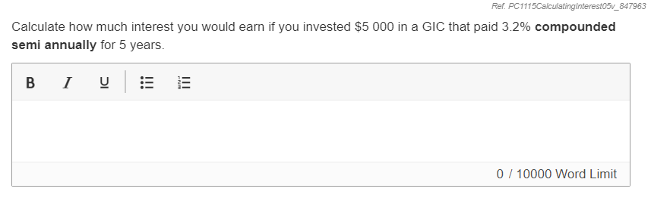
What student/teacher sees during review/marking:
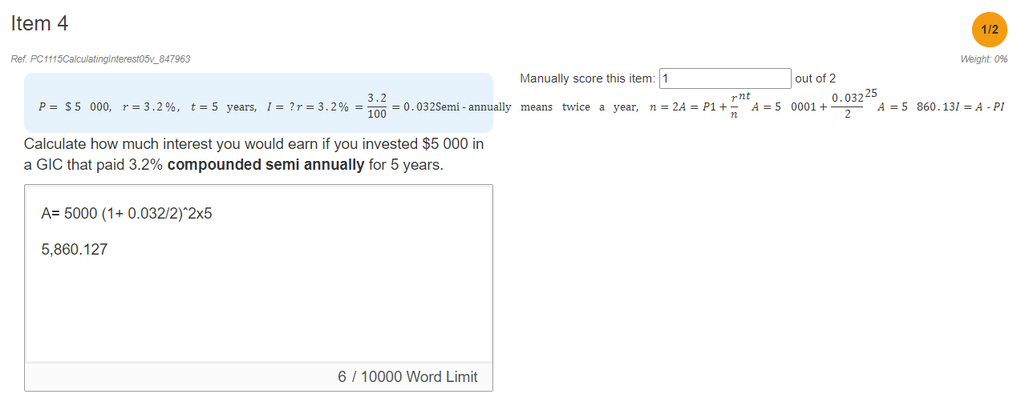

The question encoding:

{
"spellcheck": false,
"metadata": {
"distractor_rationale": "<p><iframe src=\"https://www.youtube.com/embed/pG95FIKYO1Q?rel=0\" frameborder=\"0\" width=\"640\" height=\"360\"></iframe></p>"
},
"ui_style": {
"fontsize": "large"
},
"validation": {
"max_score": 2
},
"type": "longtextV2",
"is_math": true,
"stimulus": "<p style=\"margin-bottom: 0cm;\">Calculate how much interest you would earn if you invested $5 000 in a GIC that paid 3.2% <strong>compounded semi annually</strong> for 5 years.</p>",
"instructor_stimulus": "<p><math xmlns=\"https://www.w3.org/1998/Math/MathML\"><mi mathsize=\"14px\">P</mi><mo mathsize=\"14px\">=</mo><mo mathsize=\"14px\">$</mo><mn mathsize=\"14px\">5</mn><mo mathsize=\"14px\">&nbsp;</mo><mn mathsize=\"14px\">000</mn><mo mathsize=\"14px\">,</mo><mo mathsize=\"14px\">&nbsp;</mo><mi mathsize=\"14px\">r</mi><mo mathsize=\"14px\">=</mo><mn mathsize=\"14px\">3</mn><mo mathsize=\"14px\">.</mo><mn mathsize=\"14px\">2</mn><mo mathsize=\"14px\">%</mo><mo mathsize=\"14px\">,</mo><mo mathsize=\"14px\">&nbsp;</mo><mi mathsize=\"14px\">t</mi><mo mathsize=\"14px\">=</mo><mn mathsize=\"14px\">5</mn><mo mathsize=\"14px\">&nbsp;</mo><mi mathsize=\"14px\">years</mi><mo mathsize=\"14px\">,</mo><mo mathsize=\"14px\">&nbsp;</mo><mi mathsize=\"14px\">I</mi><mo mathsize=\"14px\">=</mo><mo mathsize=\"14px\">?</mo><mspace linebreak=\"newline\"></mspace><mi mathsize=\"14px\">r</mi><mo mathsize=\"14px\">=</mo><mn mathsize=\"14px\">3</mn><mo mathsize=\"14px\">.</mo><mn mathsize=\"14px\">2</mn><mo mathsize=\"14px\">%</mo><mo mathsize=\"14px\">=</mo><mfrac><mrow><mn mathsize=\"14px\">3</mn><mo mathsize=\"14px\">.</mo><mn mathsize=\"14px\">2</mn></mrow><mn mathsize=\"14px\">100</mn></mfrac><mo mathsize=\"14px\">=</mo><mn mathsize=\"14px\">0</mn><mo mathsize=\"14px\">.</mo><mn mathsize=\"14px\">032</mn><mspace linebreak=\"newline\"></mspace><mi mathsize=\"14px\">Semi</mi><mo mathsize=\"14px\">-</mo><mi mathsize=\"14px\">annually</mi><mo mathsize=\"14px\">&nbsp;</mo><mi mathsize=\"14px\">means</mi><mo mathsize=\"14px\">&nbsp;</mo><mi mathsize=\"14px\">twice</mi><mo mathsize=\"14px\">&nbsp;</mo><mi mathvariant=\"normal\" mathsize=\"14px\">a</mi><mo mathsize=\"14px\">&nbsp;</mo><mi mathsize=\"14px\">year</mi><mo mathsize=\"14px\">,</mo><mo mathsize=\"14px\">&nbsp;</mo><mi mathsize=\"14px\">n</mi><mo mathsize=\"14px\">=</mo><mn mathsize=\"14px\">2</mn><mspace linebreak=\"newline\"></mspace><mi mathsize=\"14px\">A</mi><mo mathsize=\"14px\">=</mo><mi mathsize=\"14px\">P</mi><msup><mfenced><mrow><mn mathsize=\"14px\">1</mn><mo mathsize=\"14px\">+</mo><mfrac><mi mathsize=\"14px\">r</mi><mi mathsize=\"14px\">n</mi></mfrac></mrow></mfenced><mrow><mi mathsize=\"14px\">n</mi><mi mathsize=\"14px\">t</mi></mrow></msup><mspace linebreak=\"newline\"></mspace><mi mathsize=\"14px\">A</mi><mo mathsize=\"14px\">=</mo><mn mathsize=\"14px\">5</mn><mo mathsize=\"14px\">&nbsp;</mo><mn mathsize=\"14px\">000</mn><msup><mfenced><mrow><mn mathsize=\"14px\">1</mn><mo mathsize=\"14px\">+</mo><mfrac><mrow><mn mathsize=\"14px\">0</mn><mo mathsize=\"14px\">.</mo><mn mathsize=\"14px\">032</mn></mrow><mn mathsize=\"14px\">2</mn></mfrac></mrow></mfenced><mrow><mfenced><mn mathsize=\"14px\">2</mn></mfenced><mfenced><mn mathsize=\"14px\">5</mn></mfenced></mrow></msup><mspace linebreak=\"newline\"></mspace><mi mathsize=\"14px\">A</mi><mo mathsize=\"14px\">=</mo><mn mathsize=\"14px\">5</mn><mo mathsize=\"14px\">&nbsp;</mo><mn mathsize=\"14px\">860</mn><mo mathsize=\"14px\">.</mo><mn mathsize=\"14px\">13</mn><mspace linebreak=\"newline\"></mspace><mi mathsize=\"14px\">I</mi><mo mathsize=\"14px\">=</mo><mi mathsize=\"14px\">A</mi><mo mathsize=\"14px\">-</mo><mi mathsize=\"14px\">P</mi><mspace linebreak=\"newline\"></mspace><mi mathsize=\"14px\">I</mi><mo mathsize=\"14px\">=</mo><mn mathsize=\"14px\">5</mn><mo mathsize=\"14px\">&nbsp;</mo><mn mathsize=\"14px\">860</mn><mo mathsize=\"14px\">.</mo><mn mathsize=\"14px\">13</mn><mo mathsize=\"14px\">-</mo><mn mathsize=\"14px\">5</mn><mo mathsize=\"14px\">&nbsp;</mo><mn mathsize=\"14px\">000</mn><mspace linebreak=\"newline\"></mspace><mi mathcolor=\"#0000FF\" mathsize=\"14px\">I</mi><mo mathcolor=\"#0000FF\" mathsize=\"14px\">=</mo><mo mathcolor=\"#0000FF\" mathsize=\"14px\">$</mo><mn mathcolor=\"#0000FF\" mathsize=\"14px\">860</mn><mo mathcolor=\"#0000FF\" mathsize=\"14px\">.</mo><mn mathcolor=\"#0000FF\" mathsize=\"14px\">13</mn></math></p>",
"instant_feedback": false
}

