A
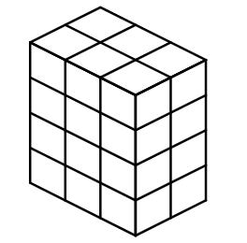

B
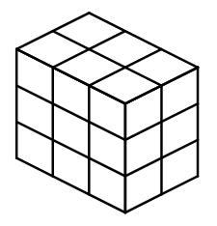

1
2 × 3 × 4 = 24

2
2 × 3 × 3 = 18

3
3 × 3 × 3 = 27

