Situation 1

Tyler poured 15 cups of water into 2 equal-sized bottles and filled each bottle.

How much water was in each bottle?

Situation 2

Kiran poured 15 cups of water into equal-sized pitchers and filled 1½ pitchers.

How much water was in the full pitcher?

Situation 3

It takes 15 cups of water to fill ⅓ pail.

How much water is needed to fill 1 pail?
Diagram 1

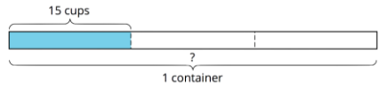

Diagram 2
