1
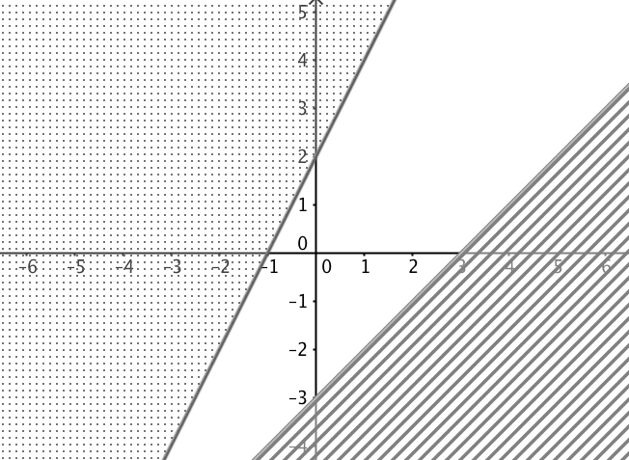
2
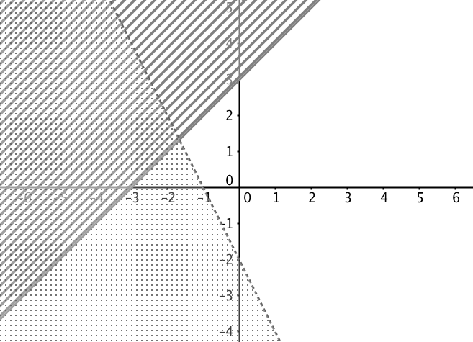
A
y < x + 3
y ≥ -2x -2

B
y ≤ x - 3
y ≥ 2x + 2

C
y ≥ x + 3
y < -2x -2

