1

2

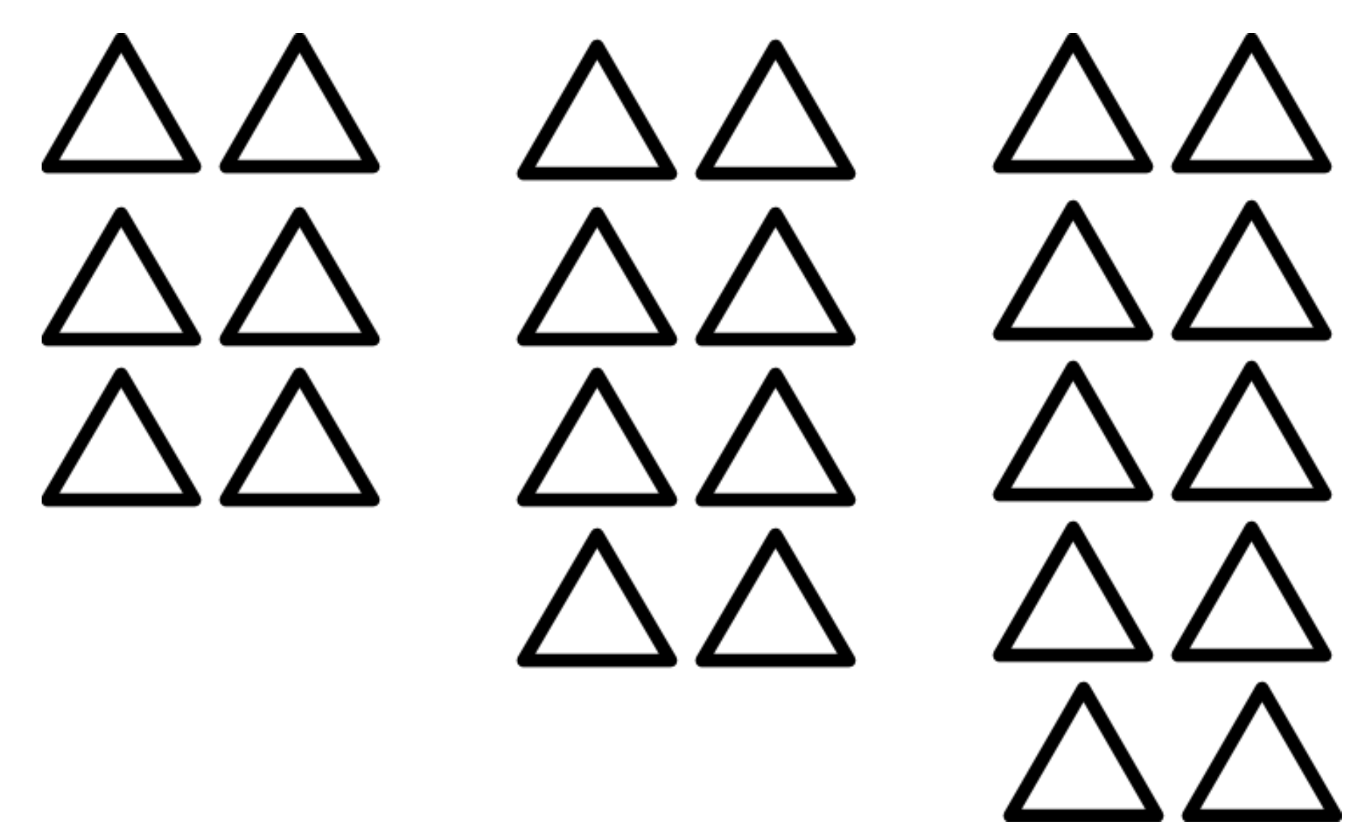
A
a_{n} = 6 + 3n

B
a_{n} = 6 + 2n

C
a_{n} = 6n + 2

