1
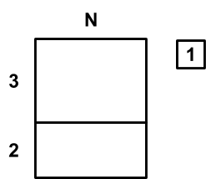

2
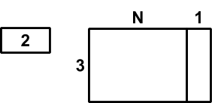

A

2 + (3 × N) + 1

B

(2 + 3) × N + 1

C

2 + 3 × (N + 1)

