Distribution A

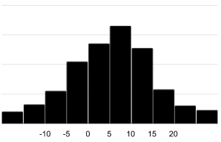

Distribution B

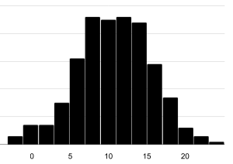

Information 1

The mean is 5 and the standard deviation is 10.

Information 2

The mean is 10 and the standard deviation is 0.

Information 3

The mean is 10 and the standard deviation is 5.

