A
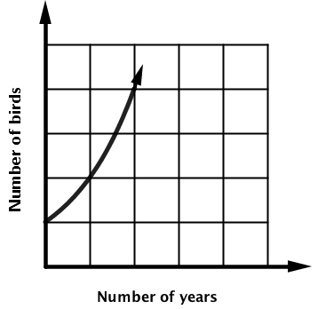
B
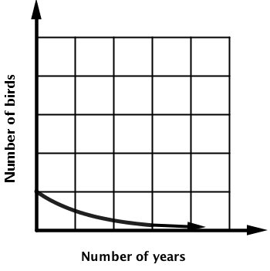
C
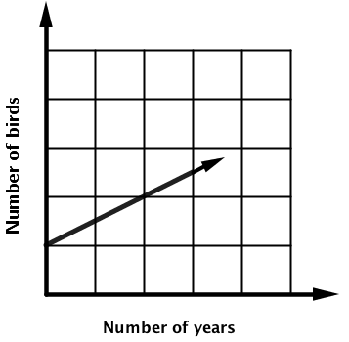
1
A population that initially has 20 birds approximately increases by 10 every 10 years.

2
A population that initially has 20 birds approximately doubles every 10 years.

3
A population that initially has 20 birds approximately halves every 10 years.

4
A population that initially has 20 birds approximately decreases by 10 every 10 years.

