A
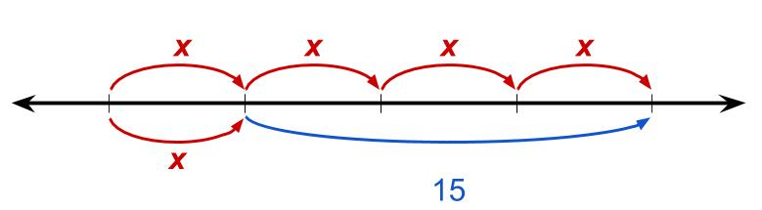
B
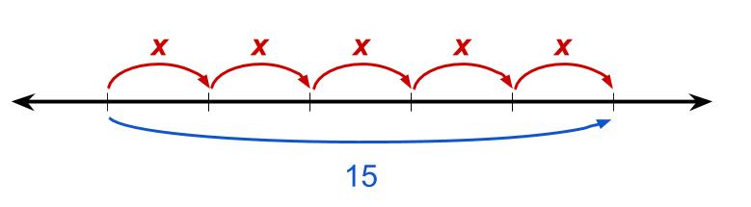
C
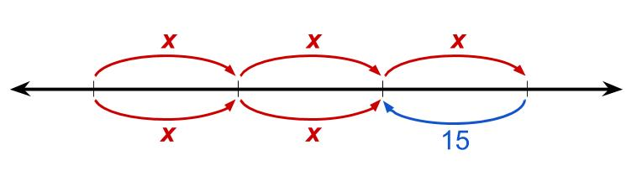

1
5x = 15

2

4x = 15 + x

