Graph A
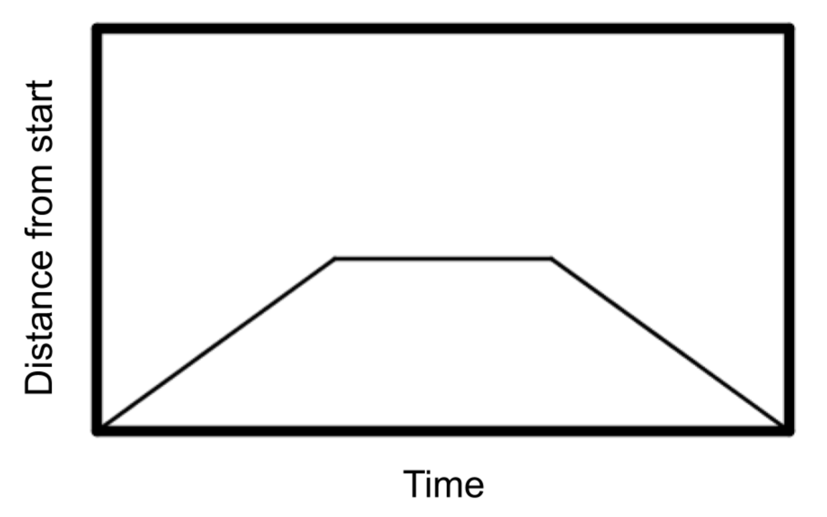
Graph B
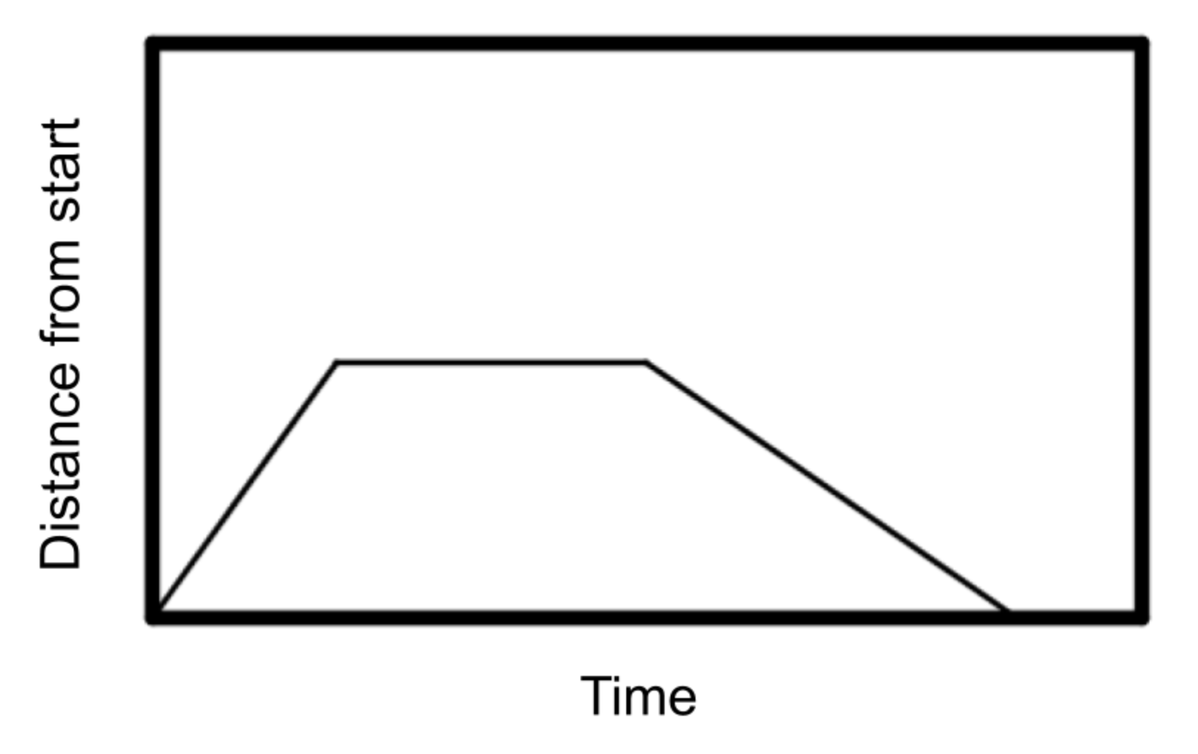
Description 1
Chiemeka is in gym class. She walked straight for 100 meters on the track and stopped to rest and then walked back to the start.

Description 2
Chiemeka is in gym class. She ran straight for 100 meters on the track and stopped to rest and then walked back to the start because she was tired.

Description 3
Chiemeka is in gym class. She ran straight for 100 meters on the track, then she walked slowly for another 100 meters further, and then ran the last 100 meters.

