A
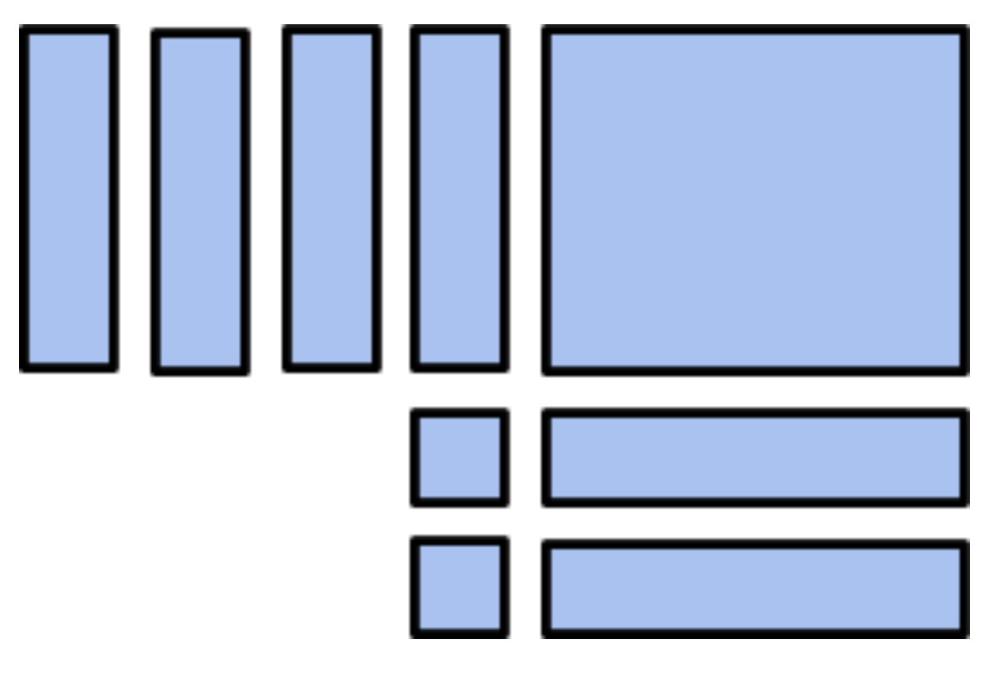
B
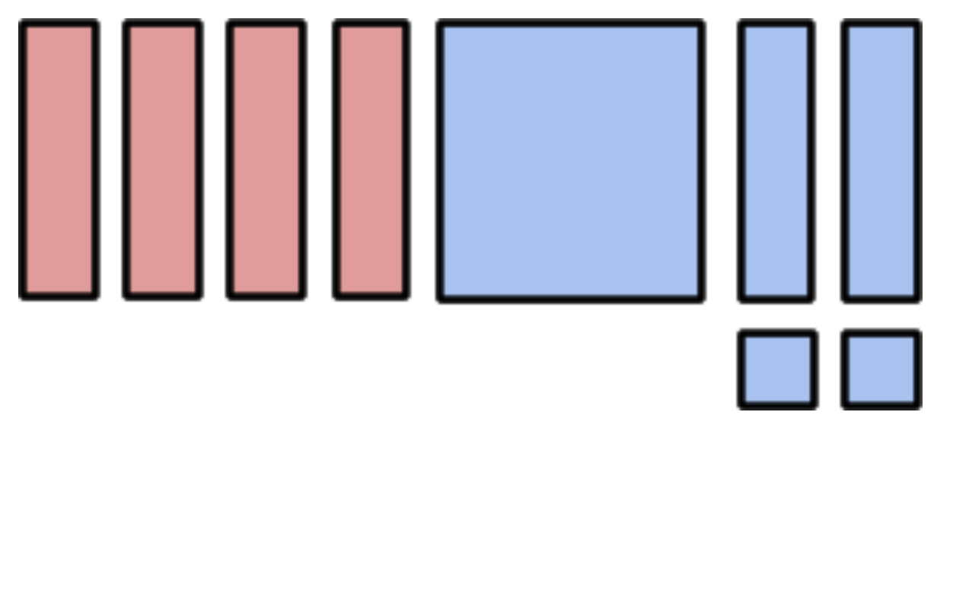
1

2x² + 2x - 4x + 2

2

xy + 2y + 4x + 2

3

2x - 2y + 4x + 2

