Name: Date:
Unit 2 ~ Writer’s Notebook

Student Instructions:
Complete the following learning guide as you work through the related lessons. You are required
to have this package completed BEFORE you go on to the next unit. Do your best. Ask your home facilitator for help as needed and contact your teacher if you have further questions. See below for the Learning Guide marking rubric.

Home Facilitator Instructions:
As soon as the student has completed a worksheet or two, please review responses together. Talk about sections where the student excelled and sections where the student had any difficulty. Students learn more if they can get feedback as they progress through the course.

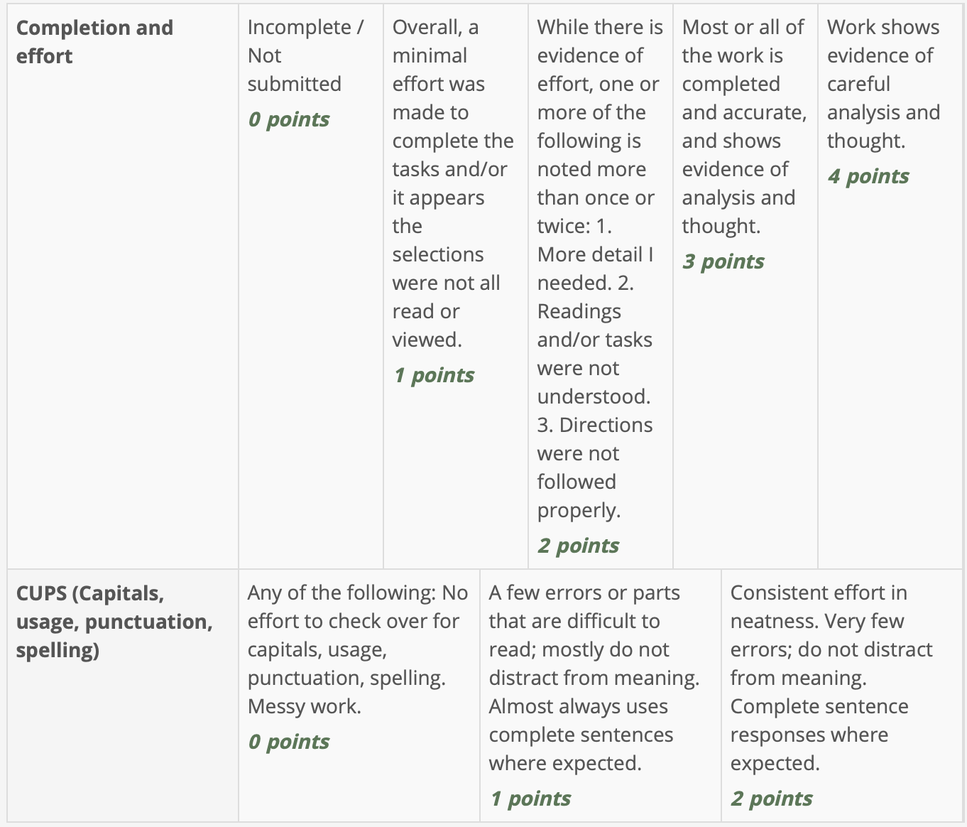
Name: ** Date: **
1. Quotation Marks
Directions: In red, add the quotation marks (“ ”) to the sentences below. Also, in the blank(s), choose whether to add a comma (,), a period (.), an exclamation mark (!), or a question mark (?).
Example: “Did you get a haircut?” Ophelia asked. “I really like it!”
1. I can’t come over today, Jessica, I have to study for the vocabulary test_ Martha said on the telephone.
2. Are we having chicken for dinner_ Lucy asked.

3. I went to the baseball game with my Dad_ Jimmy said_ and I got a hotdog and a soda.

4. Oh wow_ Luise exclaimed. Did you see that shooting star_

5. Marcus and Julius are monozygotic twins_ Harriet said. This means they’re identical twins.

6. I got an F on my vocabulary test_ Martha said with a sigh_ so I’m grounded for the next month.

7. My favourite book is Jurassic Park by Michael Crichton_ Brendan said.
8. Every day when Suzie’s mom dropped off Suzie she told her_ I hope you have a good day!

9. Yelena was shuffling papers when she suddenly said_ Ouch! She looked at her finger_ I got a paper cut!

10. Do you know where the library is_ Octavia asked_ I thought it was on Tyson, but I can’t find it_

2. Choosing Your Story Type
In the middle column, identify a short story, book, or movie you have seen or read that matches each story type listed. Explain the characteristics your title has that make it fit the story type or genre in the third column.

Here's an example:
Story type: Adventure | Title: Hatchet | Characteristics: the main character gets stranded in the wilderness when his plane crashes; he has to overcome many obstacles to survive; in just about every chapter he faces a new challenge

Your Turn:
Story Type | Title | Characteristics
Adventure | ** | **
Fantasy | ** | **
Folk Tale | ** | **
Historical  Fiction | ** | **
Mystery | ** | **
Realistic  Fiction | ** | **
Science  Fiction | ** | **
What story genre will you write? **

3. Setting
1. Word Choice: Reread the following paragraph, paying attention to Word Choice. Underline words and phrases in this setting that are especially descriptive.
The old barn is cool and cavernous. Its walls offer shelter to many creatures. Particles of straw and dust dance in the shafts of light that pierce the gentle gloom. Earthy smells drift by. In the distance a dusty road winds uphill through a tunnel of maple trees. The scent of lavender perfumes the air, and the early afternoon sun glitters on the wings of bees.
2. Give two examples of alliteration from the setting above. (Point form is fine.)
a) **
b) **
3. Give examples of sensory language (sight, smell, touch/feel, sound).
a) **
b) **
c) **
4. Where will your story take place? Will it be in the past, present, or future? Will it be set in another country, in an imaginary world, or in your own backyard? Will it be happy, scary, or exciting? Describe this setting in the space provided.
This assignment can be done as point form notes, paragraphs (see example), a web outline, drawing with captions, or another form of your choice.

Example:
The story takes place in Nepal and in the lower regions of Mount Everest. It is quite muddy at the bottom and kind of like a jungle. As they climb, the air gets thinner and colder. The mountain is covered with snow and ice. There is a lot of fog making it hard for the climbers to see where they are going at times. The mountain is very steep in places

4. Conflict
Directions: Choose three of the different kinds of conflict and give examples of how you have experienced each type of conflict in your own life. (person/character vs. person/character, person vs. nature, person vs. self, and/or person vs. society) (NOTE: Give the type of conflict, and in 1-3 sentences, explain each example.)
Example One – Person vs. **
**
Example Two – Person vs. **
**
Example Three – Person vs. **

**

5. Characters
Word Choice
1. In the following character description, underline words or phrases that are especially well written.
From The Black Cauldron by Lloyd Alexander (Henry Holt, 1965)
A bellow of laughter resounded beyond the chamber, and in another moment a giant, red- headed warrior rolled in at the side of Adaon. He towered above all in the chamber and his beard flamed around a face so scarred with old wounds it was impossible to tell where one began and another ended. His nose had been battered to his cheekbones; his heavy forehead was nearly lost in a fierce tangle of eyebrows; and his neck seemed as thick as Taran’s waist. (p. 25)
2. Find three vivid verbs that are used in unusual ways. (Remember, verbs are action words or words like is/was/are/were. (Hint: First letters could be r, t, b)
** ** **
3. In the following character description, underline words or phrases that are especially well written.
From Look Homeward, Angel by Thomas Wolfe (Simon & Schuster, 1995, originally published 1929)
My brother Ben’s face, thought Eugene, is like a piece of slightly yellow ivory; his high white head is knotted fiercely by his old man’s scowl; his mouth is like a knife, his smile the flicker of light across a blade. His face is like a blade, and a knife, and a flicker of light: it is delicate and fierce, and scowls beautifully forever, and when he fastens his hard white fingers and his scowling eyes upon a thing he wants to fix, he sniffs with sharp and private concentration through his long, pointed nose...his hair shines like that of a young boy—it is crinkled and crisp as lettuce. (p. 135)
4. Find and copy three examples of simile (comparisons using like or as)
**
**
**
Think of two main characters for your story. Describe how each of your characters looks, what their likes and dislikes are, and any strange or special behaviours they might have. An example is provided for you.

Example:
Character: | Description
Sarah Mulligan | Sarah is a fourteen-year-old girl from Alberta. She has straight brown hair, brown eyes, and is very strong and fit. She likes mountain climbing and trekking and travels a lot with her parents to do this. Sarah likes the adventure but sometimes wishes she could stay in one place and be a normal kid who just hangs out with her friends.
** | **
** | **

6. Plot
What will the key events in your story be? How will the conflict be overcome, or will it?
Outline the plot of your story in point form, a web, or in short paragraphs like in the example below. Make sure you have a believable situation, rising action with an interesting conflict, a climax that will grab the reader, falling action, and a conclusion that ties up all the loose ends.
Character: | Description
Exposition | Introduce the characters, setting, problem  **
Rising Action | Events building up to the climax, growing conflict / complications  **
Climax | The turning point and the most exciting part of the story  **
Falling Action / Resolution | Shows the aftermath after the conflict and loose ends are tied up/the ending of the story  **

Review the elements of a story – setting, character, conflict, plot (exposition, rising action, climax, falling action, resolution). Then complete the “Elements of a Story” Quiz.

Submit this Writer’s Notebook to your teacher now using the drop box.

