Name: ****

Unit 2 ~ Learning Guide

Student Instructions:

Complete the following learning guide as you work through the related lessons. You are required to have this package completed BEFORE you go on to the next section or unit. Do your best. Ask your home facilitator for help as needed and contact your teacher if you have further questions. See below for Learning Guide marking rubric.

Home Facilitator Instructions:

As soon as an entry or two have been completed, please discuss the work together. Ask questions, encourage elaboration and use of specific details. Insist on (and support learning of) proper capitalization, grammar, and punctuation where complete sentence answers are expected. Immediate feedback will enhance learning as the student progresses through the course.

Ideas and Content | Not enough completed to assess this area. 0 points Not yet meeting expectations, significant amounts not completed. 1 point Not yet meeting expectations. Some parts not completed or not minimally acceptable. 2 points Minimally Meets Expectations - some detail, attempts to respond with minimally acceptable accuracy. 3 points Meets Expectations - reasonable detail, responses mostly complete. Most directions followed. There is some attempt to respond to a topic if it has been provided. Comprehension of most concepts is evident. 4 points Fully Meets Expectations - neat, very good detail and responses. You generally attempt deeper thinking in your responses when possible. Directions followed carefully. Comprehension is clearly evident. 5 points Exceeds Expectations - neat, exceptional detail, thoughtful responses. You always attempt deeper thinking in your responses, when possible. The topics have been addressed thoroughly and correctly. Directions followed carefully. 6 points
Organization & Conventions | Entries have many errors in sentence structure, grammar, and punctuation that make them difficult to read and/or not enough completed to assess this area. 0 points Errors in sentence structure or grammar may make it difficult to follow. May lack effort in these areas. 1 point Some errors in grammar, spelling, or sentence structure, but they do not impact readability. 2 points Entries are easy to read and understand with just a few minor errors in spelling punctuation and grammar. Complete sentences in evidence where requested. Effort to use/fix work to attempt correct capitalization and punctuation is obvious. 3 points
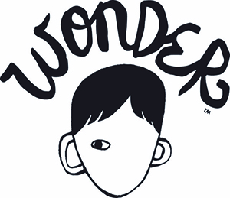
Date: ****
2.1A – Wonder

Directions: Respond to the following questions in complete sentences.

In some stories, you learn a lot about some of the characters. You learn about personal identity – how people think about themselves, what characteristics define them, and what makes them unique. What do you learn about the main character in the excerpt from the beginning of the novel, Wonder?

- Why do people look quickly away when they first see August?

****

- Do you think August should go to school? Why or why not?

****

- How does August’s family feel about him? How do you know?

****
Using the style of writing in the excerpt from Wonder, in questions 4 and 5, tell about yourself. If this book was about you, what we learn about your personal identity. What are your personal characteristics? What are you like? What do you like?
4. I know I am not an ordinary **** year old. I mean, sure I do ordinary things. I ****, ****, ****. And I feel ordinary. Inside. But I know ordinary kids don’t **** and **** like I do.

5. If I had one wish, I would wish that I ****.

Date: ****
2.1B Each Kindness
We look at things and people, without really seeing them – without understanding them. To look at something is to gaze your eyes upon something and just know it’s there. To truly see and understand something, you need to look past the obvious appearance in order to pay attention and truly understand.

1. For each text and image below, tell what the students saw/thought/did and what they should have seen/thought/done instead. (Point form on the chart is fine.)

 | What the students saw, thought, and did | What the students should have seen, thought, and done
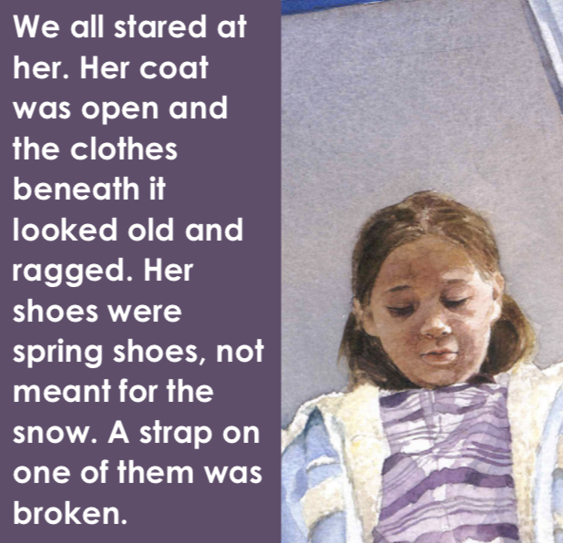 | ** | **
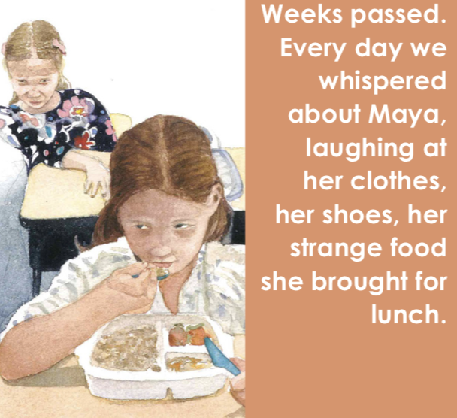 | ** | **
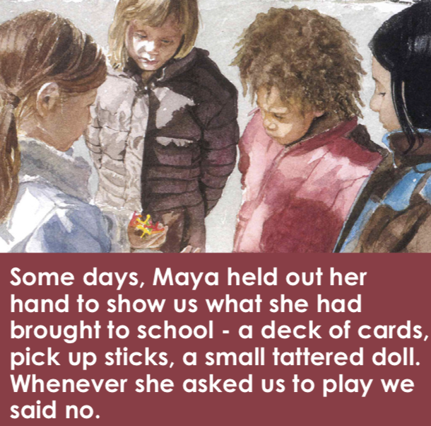 | ** | **
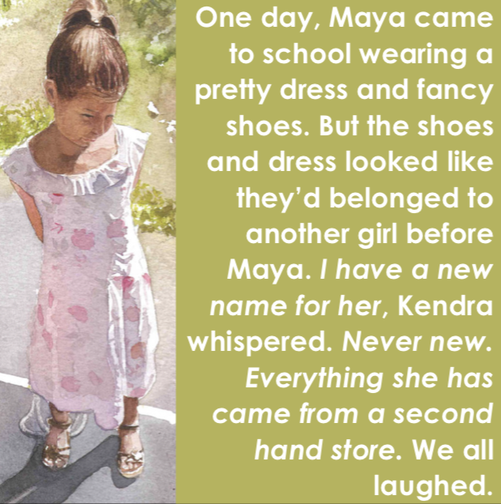 | ** | **

2. If you saw beyond Maya’s appearance how would you describe her. What clues does the text reveal about Maya’s personality and internal traits?

****

3. Who could Maya seek out to ask for help? What should she say to them?

****

4. Kindness is like tiny waves “each little thing we do goes out, like a ripple into the world.” Chloe was unable to think of even a tiny kindness she had done. What small act of kindness could Chloe have shown during the story?

****

5. Which character was “dynamic” (changed)? How do you know?

****

6. What is something you did or said in the last 24 hours that shows something about what kind of person you are? What does it show or tell us about you?

****

Date: ****

2.1C Bronia and the Bowls of Soup
Directions: Respond to the following questions in complete sentences.

1. Does this narrative focus on personal identity or cultural identity? How do you know?
****
2. What was the important lesson the author learned as a child? (answer on pages 8-9)
****

3. Find details in the story that show how life was for Bronia before the war, during the war, and after the war. Put at least three facts (and page numbers) in each section on the chart. Point for is acceptable for this. The first column is done for you.

BEFORE THE WAR | DURING THE WAR | AFTER THE WAR
Family owned clothing store (p.3)  Enjoyed ice cream treats / movies (p.3)  Went to school (p.3) | *** | ***

4. Tell about an object in your house that represents a piece of family history OR think of a family member/elder who could tell you stories about an aspect of your cultural heritage. (You may need to ask your home facilitator for ideas and stories to respond to this open-ended question.) What is the object/person? What does it represent?

****

5. You ask questions every day but have you ever thought about what makes a good question? You use different types of questions for different reasons.
- Yes or no questions are used when you want a simple yes or no answer but you don’t want too much information.
  - For example, “Is it raining outside?”
- Specific questions are used when you want a simple answer but yes or no would not give you the information you need.
  - For example, “What is your favourite book?”
- Open-ended questions have many possible answers and suggest a detailed response is in order.
  - For example, “Could you tell me about your favourite book?” invites details.
2. Write questions that would help you get detailed information about a special object, story, or memory from a relative or someone with the same cultural background as you. Then, in point form, tell if it is a specific question or an open-ended question. Try not to use yes/no questions.

a) ****
Type of question: ****

b) ****
Type of question: ****

c) ****
Type of question: ****

3. The family in the writing belonged to the Polish Jewish community and then became Americans. What are some different groups you belong to? (heritage, culture, languages, beliefs, locations)

****

Date: ****
2.1D Genres
Directions: Read the following book summaries and see if you can figure out their genres. Some of the books also have questions about personal or cultural identity. All the books listed are by Canadian authors.
1) The Prince of Neither Here Nor There by Seán Cullen
This book is about Brendan Clair who lives in Toronto and is having an awkward start to high school. As he tries to fit in, a strange woman visits Brendan and he finds out that he is not human – he’s a faerie. Brendan discovers mystical realms in his city and learns his destiny is to help save the human race.
Genre: ****
How do you think Brendan’s discovery of his identity as a faerie might help him?
****

2) The Tiffin by Mahtab Narsimhan
This story is about a boy named Kunal who lives in Mumbai, India. He lives in a difficult foster home and decides he has had enough. Full of hope for a better life, he heads out on a search to find his mother.
Genre: ****

3) Naomi's Road by Joy Kagawa
This book looks at the internment of Japanese-Canadians during World War Two through the eyes of a young girl named Naomi. The Canadian government ordered all Japanese-Canadian on the coast of BC to be relocated to labour camps in the interior of BC or in Alberta. Naomi copes with losing her home in Vancouver and the racism of the time period.

Genre: ****

What was happening in BC during World War Two that was racist and not positive for Japanese-Canadians?
****

4) Quista by Aviva Bel’Harold
Danay lives on the water planet of Uma’Three. She feels like an outsider because her skin dries out in the water and she doesn’t have second lungs like everyone else. But she realizes her problems are small when the Emperor arrives to perform loyalty tests and her best friend is taken away. Danay must find strength within herself as she does all she can to save her friend.
Genre: ****

Tell about (describe) a time when you felt like an outsider.
****

5) Barkerville Gold by Dayle Campbell Gaetz
Rusty, Katie, and Sheila are budding detectives who are visiting Barkerville – a town known for its gold rush history. The three friends are searching for clues to find a fortune in missing gold, so they can return it to the rightful owners. But could their lives be at risk? There is talk in town that a miner went missing because the gold was cursed a hundred years ago.
Genre: ****

6) 28 Tricks for a Fearless Grade 6 by Catherine Austen
Dave Davidson is on mission to help all his friends lose their fears. But his ideas lead to all sorts of hilarious mishaps and hijinks. A friend says he was afraid of public speaking. Dave’s solutions are to get friends to hold up cue cards, get laryngitis or forge a note from a therapist.
Genre: ****
Describe a fear that is helpful. How is it helpful?
****

7) Shipwreck! By Frieda Wishinsky
Sarah and Albert are two young friends from Liverpool, England who are excited to be sailing to Canada - an adventure of a lifetime back in 1914. It's early in the morning when they feel the ship, Empress of Ireland, give a sharp jolt…and then it begins to tilt! Passengers scream and run for lifeboats. Find out how Sarah and Albert survive this disaster at sea.
Genre: ****

8) What genre was the story, “Each Kindness”, from lesson 2.1C? What are two pieces of evidence from the story that support your choice?
Genre: ****
Evidence: ****
Evidence: ****

9) If a writer was going to write a story about something to do with your life, what genre would you like the writer to use? Why?
Genre: ****

Once you feel you have a handle on your different genres, complete the online Know Your Genres Quiz.

Date: ****
2.1E The Giant Who Cried Waterfalls – Part One

Setting
What do we learn about the village and the scenery around it? Revisit the text and choose to:
a) Write point form notes about the village and surrounding scenery. Where, when, and in what atmosphere will the story take place?

****

OR
b) Draw a pencil sketch of the village and surrounding scenery.

Return to the online lesson.

Character
Character is often the most important element of story. Usually one character is fully developed and 2 or 3 supporting characters are introduced and developed. How and what do we know about Bonnie up to the end of page 6?

1. Appearance: What do we learn about the character’s physical appearance? (We only learn a little bit about this.)

****

2. Action: What do the character’s actions show us about what she is like? Tell the actions and describe what each one shows.

****

3. Monologue: What does the character think or say to herself that shows her inner character? Give specific examples from the text.

****

4. Dialogue: What does the character say that shows her inner character? Give a specific example from the text.

****

5. Based on what you’ve learned so far, would you say Bonnie is naughty or nice? Explain.

****

Your Character – A Personal Identity Reflection
Directions: Think of how people may perceive you. By looking at you, can they tell your cultural background – where your family may have originally been from? Anything else? Based on your actions and words, how might others describe you? Is this the same or different from how you view yourself? Complete the following sentences.

Based on my appearance, people may think or know…
****

Based on my words and actions, people can see that I…
****

The way others perceive me is: **** (the same as, different) from the way I perceive myself. I know this because:

****

Date: ****
2.1F The Giant Who Cried Waterfalls – Part Two

Personal Values and Choices – TOP FIVE
Directions: Create your own top 5 list. From the values in the lesson, what are the top 5 most important for you in your own life?

1. ****

2. ****

3. ****

4. ****

5. ****

Tell about how one or more of these values impacted a decision or choice you had to make.

****
Return to the online lesson.

Bonnie’s Top Five Values List

Directions: Create Bonnie’s top 5 list. Based on the story, what are the top 5 most important values for Bonnie? Support each choice with evidence. Point form evidence is acceptable for this assignment.

Value | Evidence from the story
*** | ***
*** | ***
*** | ***
*** | ***
*** | ***

Explain, in a paragraph, one example of how Bonnie’s values impact her decisions. Be sure to use capitals and punctuation.

***

Date: ****
2.1G End of the Line
Plot
Directions: Answer the questions about different parts of the plot.

1. Exposition: introduces you to the characters, setting, and problem:
In point form, tell three traits you learn about each of the following characters and their personal identities in the exposition:
a) Frank - ***
b) Liza - ***
c) Zedekiah Smith - ***
2. What is the problem? What does Liza want to be able to do? (Use the key words in the sentence to help you form a complete sentence response.)
***
3. Where was the mine located? (Use the key words in the sentence to help you form a complete sentence response.)
***
4. Rising Action: all the events that build up to the climax, there is growing conflict that creates suspense
Tell three main “events” that occurred before the climax.
***
5. Climax: the turning point and the most exciting part of the story.
What event do you believe is the climax? Why? (Use the key words in the sentence to help you form a complete sentence response.)
***
6. Falling Action: shows the aftermath after the conflict and loose ends are tied up.
What did Frank figure out that Liza didn’t figure out until the end of the story? (Use the key words in the sentence to help you form a complete sentence response.)
***
7. Resolution: the ending of the story.
How do Liza’s words at the end of the story, “Frank… next time you have something to say, speak up. I’ll try hard to listen.” show that she learned a lesson? (Use the key words in the sentence to help you form a complete sentence response.)
***

Dig Deeper

1. Find and copy the simile (a comparison that uses like or as) in the first sentence of the story.

***

2. Find and copy the simile on the last page of the story.

***

3. What genre was the story, “End of the Line”, from lesson 2.1G? What are two pieces of evidence from the story that support your choice?
Genre: ****
Evidence: ****

4. On page 4, Zedekiah did something that was surprisingly kind for a bank robber. What did he do? Why did he say he did this?

***

Date: ****

2.1H Story Telling
Video Responses
Directions: Answer the questions in complete sentences.
1. What were the young boys in his village learning that the main character was not learning?
***
2. How did the boy’s community help him when the boy escaped his captivity and returned to his village?
***
3. What is the message of each side of the mask? Of what is it intended to remind people?
***

Connect:

4. In a few sentences, describe a story, movie, show, song, or real life experience that has a similar message to one the mask represents: “Remember – when going through a rough time: there is always a good side”.

***

5. Does your family or community or culture have stories that have been shared? If so, do these stories teach lessons? Give an example.

***

Date: ****

2.1H Story Telling

Drawing Conclusions:
Answer the following questions:

1. In the stories in this unit, identity and culture impacted how others were treated. How does your personal identity affect the way you act and how others see and treat you?

****

2. Can personal identity change? What kinds of things can you do to improve it?

****

3. Cultural identity gives certain beliefs or ideas about the world. If a person meets someone who has different beliefs and ideas (but are not hurting anyone with hate speech or prejudice), how should a person respond?

****

4. Check through your learning guide. Make any corrections, additions, and edits that are needed. Check:
- Is your name on it?
- Is each lesson dated?
- Is everything completed?
- Do sentences start with capitals and have end punctuation?

Submit this learning guide to your teacher now.

