Name:
Date:

Writer’s Notebook Unit 2

Student Instructions:
Complete the following entries after reading the instructions and/or viewing resources in your online courses. Remember:
- To complete three entries minimum for each unit of your own ideas.
- You may want to use a notebook or online tool instead for your writer’s notebook to keep everything in one place but you should still follow the format or guidelines presented here:
- Refer back to your online course for more detailed instructions (found at the top of the course)

2.1 Mentor Text: Hang Up and Drive
In point form complete the graphic organizer for the mentor text in your course.
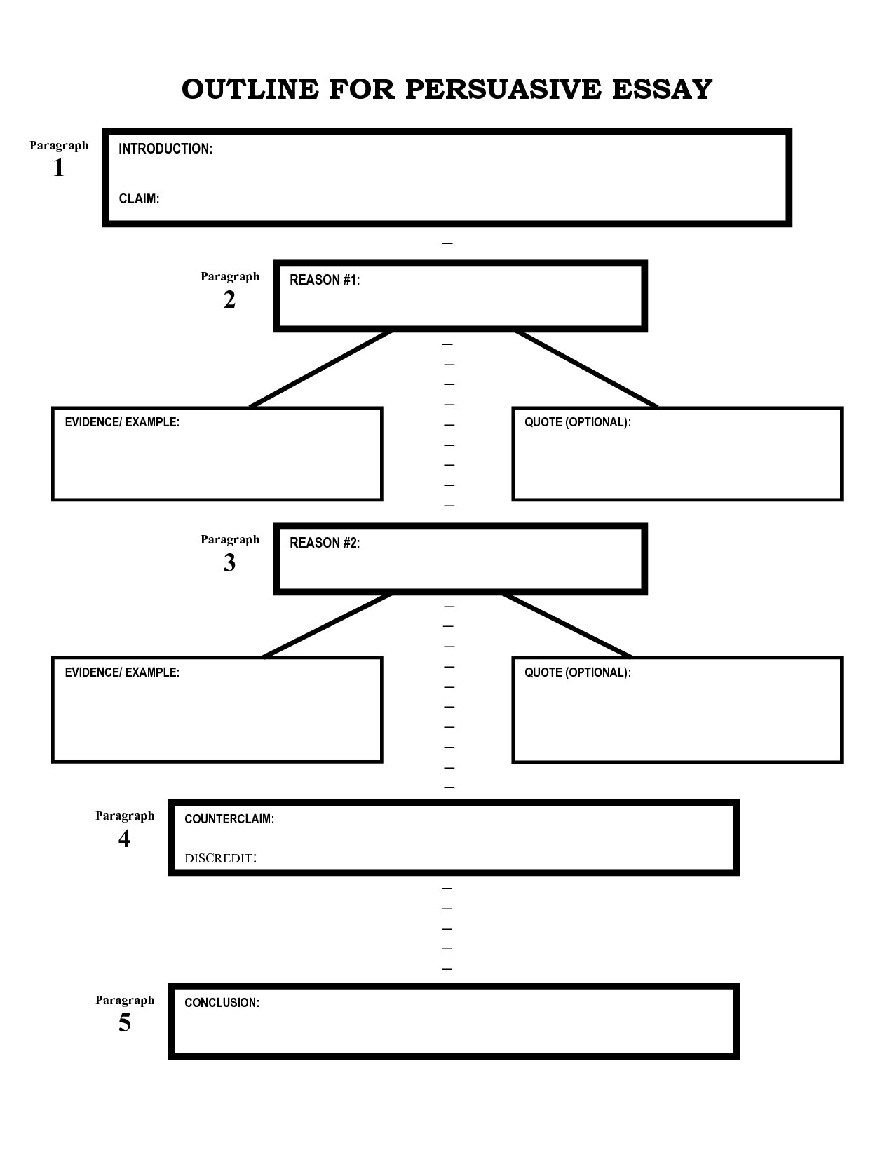
2.2 What do you want to write about?

1. List some things that occur in your life or in others' lives that bother you, make you angry or that you think should be different.

2. Think about these general categories and create an opinion statement about three (3) of them.

3. Pick four (4) areas of interest from the provided list.

4. Pick a primary focus area from the provided list and state it here.

2.3 Your Own Entry:

2,4 Your Own Entry:

2.5 Your Own Entry:

