Name: Date:

Unit 4 ~ Learning Guide

Student Instructions:
Complete the following learning guide as you work through the related lessons. You are required
to have this package completed BEFORE you go on to the next unit. Do your best. Ask your
home facilitator for help as needed and contact your teacher if you have further questions. See below for Learning Guide marking rubric.

Home Facilitator Instructions:
As soon as your student has completed a worksheet or two, please mark and go over the answers with him or her. Talk about sections where the student excelled and sections where the student had any difficulty. Students learn more if they can get feedback as they progress through the course.
Note: The total points will be out of 16.

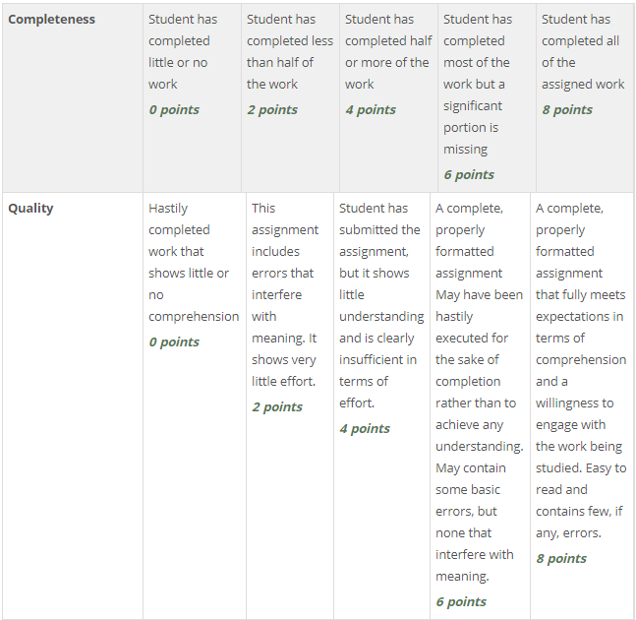

Name:____________________________ Date:_________________________

4.1 Self Portrait
Part A
1. Describe how you identify yourself. In point form, list at least 4 adjectives to describe your personal identity.

Part B
1. How does Buffy Sainte-Marie portray herself in this self-portrait? Write a brief paragraph that includes 4 adjectives.

Return to the online lesson book.
4.2 The Value of Nature Observation Exercise

Part A: The Value of Nature
In 3-5 sentences, what are your thoughts on the value of being
connected with nature? How do you connect with nature?

Part B: Observation Exercise

Whether it is a park, your backyard, a favourite hike or any natural environment go there and do the following.
1. Take a few minutes to close your eyes and just listen to any sounds that you hear.
2. Slow down and take time to feel and smell objects in nature.
3. Observe even the simplest of actions that you notice happening: how the breeze moves the grass, an insect travelling over the ground, shifting clouds etc.
4. Take a string, a metre long or a hula hoop, and make a circle on the ground. Focus very closely on what is in there.

Return to the online lesson book.
4.3 Ecosystems

Part A: Brainstorming on ONE of the pictures. A couple of examples have been shown. You will create your own description of place.
Ecosystem | Marine | Forest | Desert | Tundra
Sights
Sounds
Smells
Tastes
Textures |  | sharp pine needles
Interactions/  Connections | Crabs eat snails; snails eat algae

Part B: Descriptive paragraph
Write a descriptive paragraph about your selected ecosystem. Include the details from your brainstorming, but also include the interactions that are occurring with the ecosystem. Use imagery and figurative language to create a vivid picture.

Return to the online lesson book.
4.4 Poem - Walking Through Words

Complete the chart while listening to “Walking Through Words”

It’s Just the …. | until it’s…. | Note two descriptions
Ocean

Tree
Mountain
Sky
Write two more metaphors of your own that describe nature where you live or your connection to nature.
Example: It’s just a snowflake until it blankets the mountain in white, tucking in the earth for winter.

Return to the online lesson book.

4.5 Henry David Thoreau

Part A: "I Went to the Woods" from "Walden" Chapter 2 "Where I Lived and What I Lived For"
1. Why did he go into the woods where he lived?

2. What words in his description of place identify his preferences? What does he say he lives for?

Part B: "Walden is a Perfect Forest Mirror from Chapter 9 "The Ponds"
1. What figure of speech is being used when Thoreau says "Walden is a perfect forest mirror"?
2. In what ways does Walden Pond – and nature in general – serve as a mirror?

3. Walden was well known to Thoreau. He grew up nearby and spent many hours walking there and observing nature. Describe one of the interactions taking place in the scene Thoreau is describing. How is nature working together with itself or with man? What is the balance between civilization and nature?

4. Thoreau’s skills as a writer are clearly at work in this passage. How does art – writing, stories, music, painting, etc. – help “conserve” nature? Do you think Walden Pond would still exist today if Thoreau hadn’t written about it so eloquently?

5. Do you have a place, outside in nature, which serves as your “mirror” or brings you "liquid" joy? How has this place influenced your view of the environment and your environmental ethic? What is your Walden?
Return to the online lesson book.

4.6 Razzleberries

1. What are razzleberies?

2. What activity is described in the poem? Why is this activity difficult? Identify 2 reasons.

3. Find an example of hyperbole in the poem. What is being exaggerated?

4. Find an example of alliteration.

5. What does the poet decide in the last two lines (the couplet) of the poem?

6. What is Maracle's connection to nature as described in "Razzleberries"?

Return to the online lesson book.
4.7 Haiku

Part A: Fill in the Table

1. Find 2 examples of imagery in each of the four haiku. Identify which sense the image is using (sight, sound, taste, texture, smell).
2. Haiku are often about seasons. What season is described in each haiku?
3. What feeling does this poem give you? Try this list of emotions. (http://www.tinareber.com/wp-content/uploads/2016/06/Adjectives.png)

Author | Imagery Eg. #1 | Imagery Eg. #2 | Season | Feeling
Basho
Haiku #1
Moritake
Haiku #2
Basho
Haiku #3
Ransetsu
Haiku #4

Part B: Write your Own Haiku
Then, again go outside and observe what you see in nature. Whether it is seeing a spectacular sunset, witnessing a severe weather change, or noticing a beautiful pattern or colour in nature, sometimes a photograph can't catch your reaction to the moment, or a smell or feeling. Write two different haiku about a moment in nature you experience. You can try this haiku generator to help you with the structure. https://www.poem-generator.org.uk/haiku/
Haiku One:

Haiku Two:

Return to the online lesson book.
4.8 Cree Legend

Part A:

1. Who is Wesakechahk?

2. What season is it "in the long moon when-ravens-freeze-in-trees"? How do you know?

3. What details contribute to the description of place in this legend?

4. What is the moral of the legend?

5. What storytelling techniques does this written version of an oral legend use?

Return to the online lesson book.
4.9 Aboriginal Symbols in Nature

Use visual notetaking to summarize what each animal symbolizes. Use only key words to create a resource for quickly reviewing the meaning of each animal for your selected First Nation group.

Identify your First Nation group: ____________________________________
Submit this learning guide to your instructor now.
Beaver
Buffalo
Bear
Raven
Lynx
Fox

