Name:
Date:

Unit 3 ~ Learning Guide

Student Instructions:
Complete the following learning guide as you work through the related lessons. You are required
to have this package completed BEFORE you go on to the next unit. Do your best. Ask your home facilitator for help as needed and contact your teacher if you have further questions. See below for Learning Guide marking rubric.

Home Facilitator Instructions:
As soon as your student has completed a worksheet or two, please mark and go over the answers with him or her. Talk about sections where the student excelled and sections where the student had any difficulty. Students learn more if they can get feedback as they progress through the course.
Note: The total points will be out of 16.

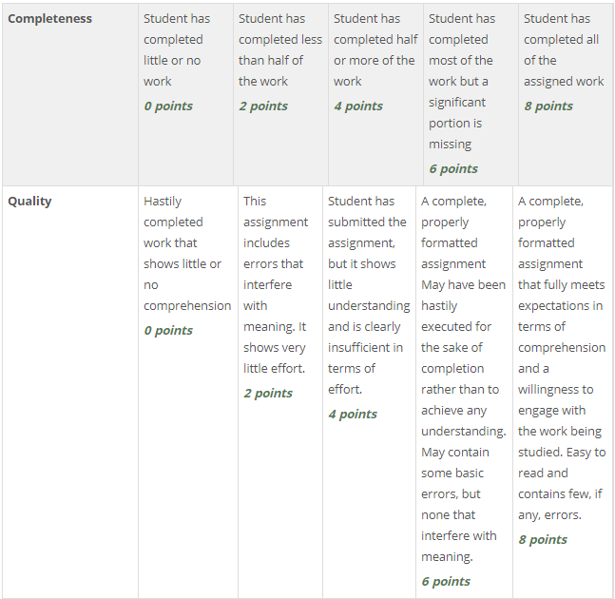

Name:____________________________ Date:_________________________

3.1 Topic Exploration
What does the future look like? What is your role in your future? What is your role in the future of the planet? Where do you fit in?
A. Autocomplete:
Describe three ways search predictions are generated
i.
ii.
iii.
Why might you not see predictions?

Do you see a problem with having your searches guided this way?

B. Two topics in autocomplete:

C. Search results and resulting topic ideas:
UrL:

Topics:

URL:

Topics:

UrL:

Topics:

UrL:

Topics:

D. 5 new categories:
1.
2.
3.
4.
5.

E. Content Curation Site: 5 lists of interest:
1.
2.
3.
4.
5.

Return to the online lesson book.

3.2 What is content curation?
1. There are a number of descriptions of content curation in this article. Copy a description that you find useful. Remember to put it in quotations and write the author’s name of the article in brackets at the end of the quote to give credit.

2. In your own words, give two reasons why curation is important.
a.
b.
3. What is “homophily” and why is it dangerous?

4. What is the difference between true curation and simple collection?

5. This article includes a number of links to videos and other articles. Choose one link to follow that piques your interest and in two sentences, summarize something you learned.

6. At the end of the article, there is a heading titled “Curation Tools” with some starting points for other resources on this topic. Pick three items from the collections that you think would be interesting or helpful in becoming a content creator and what made you choose them.
Example:

Title: The flip-a-holic’s ultimate guide to subscribing, curating and sharing using Flipboard

Reason: I have seen the flipboard tool come up as an example a number of times and what to learn more about it.
1.

2.

3.

Submit this learning guide to your instructor now.

