Name:
Date:

Unit 2: ~ Learning Guide

Student Instructions:
Complete the following learning guide as you work through the related lessons. You are required
to have this package completed BEFORE you go on to the next unit. Do your best. Ask your home facilitator for help as needed and contact your teacher if you have further questions. See below for Learning Guide marking rubric.

Home Facilitator Instructions:
As soon as your student has completed a worksheet or two, please mark and go over the answers with him or her. Talk about sections where the student excelled and sections where the student had any difficulty. Students learn more if they can get feedback as they progress through the course.
Note: The total points will be out of 16.

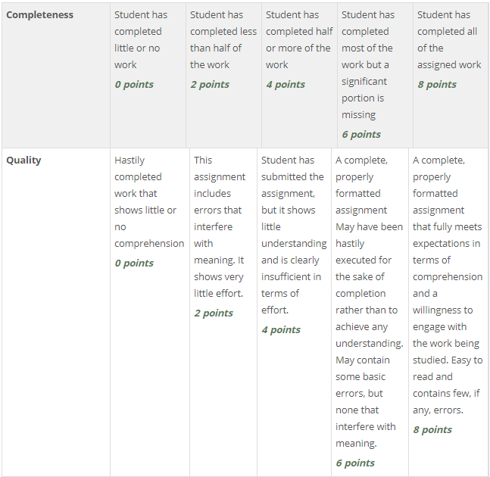

Name:____________________________ Date:_________________________

2.1 Article First Nations Storytelling
In point form make 10 points that you think are important from the article: Note: you can’t use the bulleted points at the end of the article.

1.

2.

3.

4.

5.

6.

7.

8.

9.

10 .

Return to the online lesson book.

2.2 Cree Creation Story
1. In your own words summarize the main parts of the story. You can do so in point form as you listen to the story.

2. List some things you notice about the way the storyteller tells his story. (Consider tone, pacing, gestures etc.)

2.3 Oral Telling: Flight of the Hummingbird
This story is making a comment about activism (bringing about some kind of change, whether it be social, environmental, or political).
1. In a few sentences, describe in your own words what this story is teaching.

2. Also, write about how you might become like the little hummingbird in your own world. What is one small thing you could do to bring about change?

Return to the online lesson book.

2.4 It Matters
What is the main point being made about sharing stories? Why does it matter?

2.5 Earth Story
Consider the following questions and provide a thoughtful answer.
1) Why are certain words capitalized throughout the poem?

2) Notice there are four parts to the poem. How did the author use and convey important parts of native culture to organize the poem?

3) Why do you think the last part is spaced differently?

4) Throughout this poem there are specific words that are used to describe objects (adjectives) and words used to describe actions (adverbs). Choose three of each that you think are particularly effective due to being unique and specific:
Adjectives/ Adverbs
1.
2.
3.
5) Lastly, visit the Aboriginal Arts and Stories website to see other writing by aboriginal youth:
http://www.our-story.ca/winners/writing
Submit this learning guide to your instructor now.

