Name:
Date:

Unit 1 ~ Learning Guide

Student Instructions:
Complete the following learning guide as you work through the related lessons. You are required
to have this package completed BEFORE you go on to the next unit. Do your best. Ask your home facilitator for help as needed and contact your teacher if you have further questions. See below for Learning Guide marking rubric.

Home Facilitator Instructions:
As soon as your student has completed a worksheet or two, please mark and go over the answers with him or her. Talk about sections where the student excelled and sections where the student had any difficulty. Students learn more if they can get feedback as they progress through the course.

Note: The total points will be out of 16.
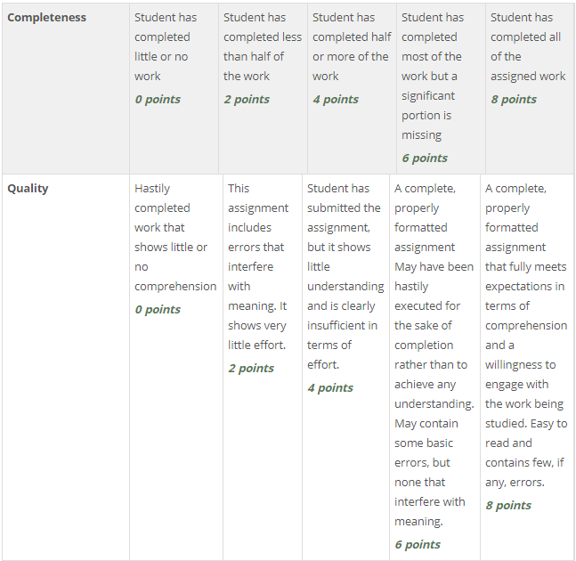
Name:____________________________ Date:_________________________

1.1 Tedtalk: What Fear Can Teach Us

Reading for Information

An s we r t h e f o l l o wi n g q u e s t i o n s :

1. In a few words explain specifically how the author gets your attention at the beginning.

2. She suggests looking at fear in a fresh way. How?

3. She suggests calling our fears stories. In a list, tell what fears have that stories do according to the author.

4. Explain the term "productive paranoia".

5. "Read in the right way", what does the author say in her conclusion that fear can offer
us?

Return to the online lesson book.

Name:____________________________ Date:_________________________

1.2 Poem: When We Come To It
Vocabulary
A. Find the definition for the following words used in the poem:
1. aloof___________________________________________________________________________
_________________________________________________________________________________
2. minstrel________________________________________________________________________
_________________________________________________________________________________
3. rapacious_______________________________________________________________________
_________________________________________________________________________________
4. kindled_________________________________________________________________________
_________________________________________________________________________________
4. kithless_________________________________________________________________________
_________________________________________________________________________________
5.sanctimonious____________________________________________________________________
_________________________________________________________________________________
6. piety___________________________________________________________________________
_________________________________________________________________________________
B. In your own words in a sentence or two describe what is the startling truth that Maya Angelou says that we are capable of "when we come to it". _________________________________________________________________________________
_________________________________________________________________________________
_________________________________________________________________________________
_________________________________________________________________________________
_________________________________________________________________________________
_________________________________________________________________________________
Return to your online lesson book.

1.3 YouTube Clip: Ski Jumper
Summarizing

An s we r t h e f o l l o wi n g q u e s t i o n s :

- What are two things that she says to talk herself into taking the jump?

B. If she were to write down her experience into a story, list in point form at least 4 sensory details that she might include (sight, sound, taste, touch, smell) to convey her fear and excitement.

Return to your online lesson book.

1.4 Short Story: Suzy and Leah
Using Evidence From Text
A. In the chart below, record three details of how Leah's experience in the war has affected her:
Diary Entry: experience in the war | What it Reveals: affect on Leah
Example: But I say that no place is safe for us. Did not the Germans say that we were safe in their camps? | Helps to explain why Leah is distrustful of people that want to help her.
1.

2.

3.

Return to your online lesson book.

1.5 Excerpt: The Absolutely True Story….
Characterization
Complete the following chart: Refer to the handout on characterization in your online book for examples. One example is listed below. You will need to find your own example.
Type of Indirect Characterization | Examples | Explanation
Speech

Thoughts

Effect on others

Actions | "It is safer to stay at home, so I mostly hang out alone in my bedroom and read books and draw cartoons." | Alexie's actions demonstrate his response to bullying which is to isolate himself and explore the development of his creative side. He is pragmatic and realistic as he is not able to defend himself yet. Avoidance is wiser for him right now.
Looks

Return to your online lesson book.
1.6 To This Day
Theme
Critical Thinking
Write a theme statement about fear for each of the selections in this unit:
Remember: Theme is NOT a summary of the plot. Theme is:
- the underlying message that the author is trying to convey
- the central thought or purpose of the story
- reflection of some important or significant aspect of life
- usually universal
Example: Life has many decisions. Life can be hard. Life can hold many regrets.

- Tedtalk: What Fear Can Teach Us

- Poem-When We Come To It

- YouTube Clip-Girl's First Ski Jump

- Short Story: Suzy and Leah

- Performed Poem: To This Day

Return to your online lesson book.

1.7 Sharing Stories
Responding to Text: Creative Thinking
1) In point form list 3-5 ways that the authors or main characters dealt with facing their fears.

2) Write about a time where you faced a fear. What strategy did you use to face your fears?

Submit this learning guide to your instructor now.

