Name:
Date:

Novel Study ~ Writer’s Workshop Notebook

Student Instructions:
Complete the following learning guide as you work through the related lessons. You are required
to have this package completed BEFORE you go on to the next unit. Do your best. Ask your home facilitator for help as needed and contact your teacher if you have further questions. See below for Learning Guide marking rubric.

Home Facilitator Instructions:
As soon as your student has completed a worksheet or two, please mark and go over the answers with him or her. Talk about sections where the student excelled and sections where the student had any difficulty. Students learn more if they can get feedback as they progress through the course.

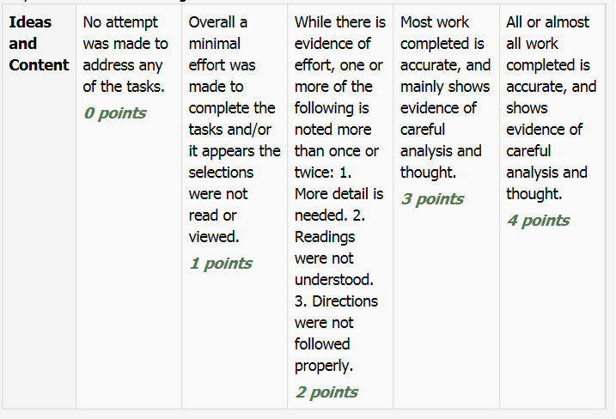
Note: While marking on a scale of 4 the total points will be out of 16.
Name:____________________________ Date:_________________________

5.1 The Main Article Notes
It’s time to begin writing the main article for your Novel News ezine assignment. Complete the following template to prepare, this can be done in point form.

Almost all news articles start off by answering most of these questions. Try to answer these questions in your article about your novel.
Who:__________________________________
What:__________________________________
When:_________________________________
Where:_________________________________

Why:___________________________________________________________________
_______________________________________________________________________
_______________________________________________________________________
_______________________________________________________________________
How:___________________________________________________________________
_______________________________________________________________________
_______________________________________________________________________
_______________________________________________________________________

Lead Sentence (a sentence that includes some of the information above and that grabs the reader)
_______________________________________________________________________
_______________________________________________________________________
_______________________________________________________________________

Return to the online lesson book.

Name:____________________________ Date:_________________________

5.2 Research
My Research Notes About ____________________________________
Name:  Date: | Research  Question 1 (Information I want to include in the article but need facts to support): | Research  Question 2 (Information I want to include in the article but need facts to support): | Research  Question 3 (Information I want to include in the article but need facts to support):
Research
Source 1

Research
Source 2

Research
Source 3

Return to your online lesson.
5.3 A Good Lead
As you work on the first draft of your main article, think about how you can grab your reader’s attention quickly by writing a good lead, topic sentence.
Write 3 possible leads for your story here:

Lead 1:
_______________________________________________________________________
_______________________________________________________________________
_______________________________________________________________________

Lead 2:
_______________________________________________________________________
_______________________________________________________________________
_______________________________________________________________________

Lead 3:
_______________________________________________________________________
_______________________________________________________________________
_______________________________________________________________________

Return to your online lesson.
5.4 Edit Your Article
Having read through editing skills specific to writing newspaper articles, it’s time to apply them! Practice your editing skills with the story below, and then edit your own article.
A large family of bats is pretty scary. They have started living on the roof of hammond elementary. Every night at that time of day when the sun is just going down they fly off the roof and circle overhead in search of food and then after about 1 hour they all return to the roof to sleep for the night. “Bats help the environment by eating mosquitoes and other harmful insects”, says Mrs. Robbbertson, our sceince teacher.
Re-write the above story with edits:
__________________________________________________________________________________
__________________________________________________________________________________
__________________________________________________________________________________
__________________________________________________________________________________
__________________________________________________________________________________
__________________________________________________________________________________
__________________________________________________________________________________
__________________________________________________________________________________
__________________________________________________________________________________
__________________________________________________________________________________
__________________________________________________________________________________
__________________________________________________________________________________
__________________________________________________________________________________
__________________________________________________________________________________
__________________________________________________________________________________
__________________________________________________________________________________
__________________________________________________________________________________
__________________________________________________________________________________

Submit this writer’s notebook to your instructor now.

