Name:
Date:

Unit 4 ~ Writer’s Workshop Notebook

Student Instructions:
Complete the following learning guide as you work through the related lessons. You are required
to have this package completed BEFORE you go on to the next unit. Do your best. Ask your home facilitator for help as needed and contact your teacher if you have further questions. See below for the Learning Guide marking rubric.

Home Facilitator Instructions:
As soon as your student has completed a worksheet or two, please mark and go over the answers with him or her. Talk about sections where the student excelled and sections where the student had any difficulty. Students learn more if they can get feedback as they progress through the course.

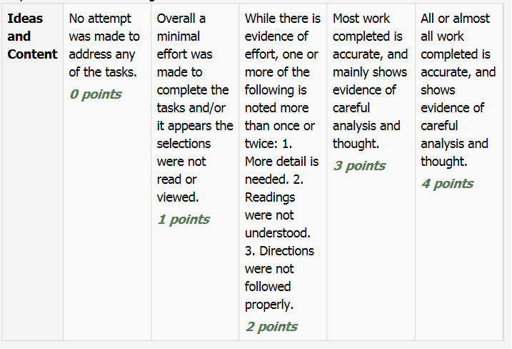
Note: While marking on a scale of 4 the total points will be out of 16.
Name:____________________________ Date:_________________________

4.1 Inspirations for Poetry

List:

A favorite memory :

A story you like to tell people :

An event in your life when you were very sad:

An event in your life when you were overjoyed:

An event in your life when you were terrified:

A time you had a conflict with someone you cared about:

Something in your life you are proud of:

An important journey or trip you took:

An experience where you did something new for the first time:

An important object from your childhood:

A time the weather scared or inspired you:

A great joy in your life:

A vacation story:

The greatest risk you have taken:

A wish that came true:

A magical place or event:

fromhttp://poetry.rcah.msu.edu/assets/lesson-plans-for-conference.pdf

4.2 Poetry Vocabulary

Poetry is … _____________________________________________________________________________________________________________________________________________________________________________
Poetic Form Words:
Form: _______________________________________________
Line: _______________________________________________
Stanza: _____________________________________________
Poetic Sound Effects Words:
Rhythm: _____________________________________________
Rhymes: _____________________________________________
Rhyme Scheme: _______________________________________
____________________________________________________
Sample Rhyme Scheme: ____________________________

Figurative Language Words:
Alliteration: _________________________________________
Simile: _______________________________________________
Metaphor: ____________________________________________
Imagery: _____________________________________________
Hyperbole: ____________________________________________
Onomatopoeia: _______________________________________
Personification: _______________________________________
Point of View:
Poet-___________________________________________
Speaker-_________________________________________

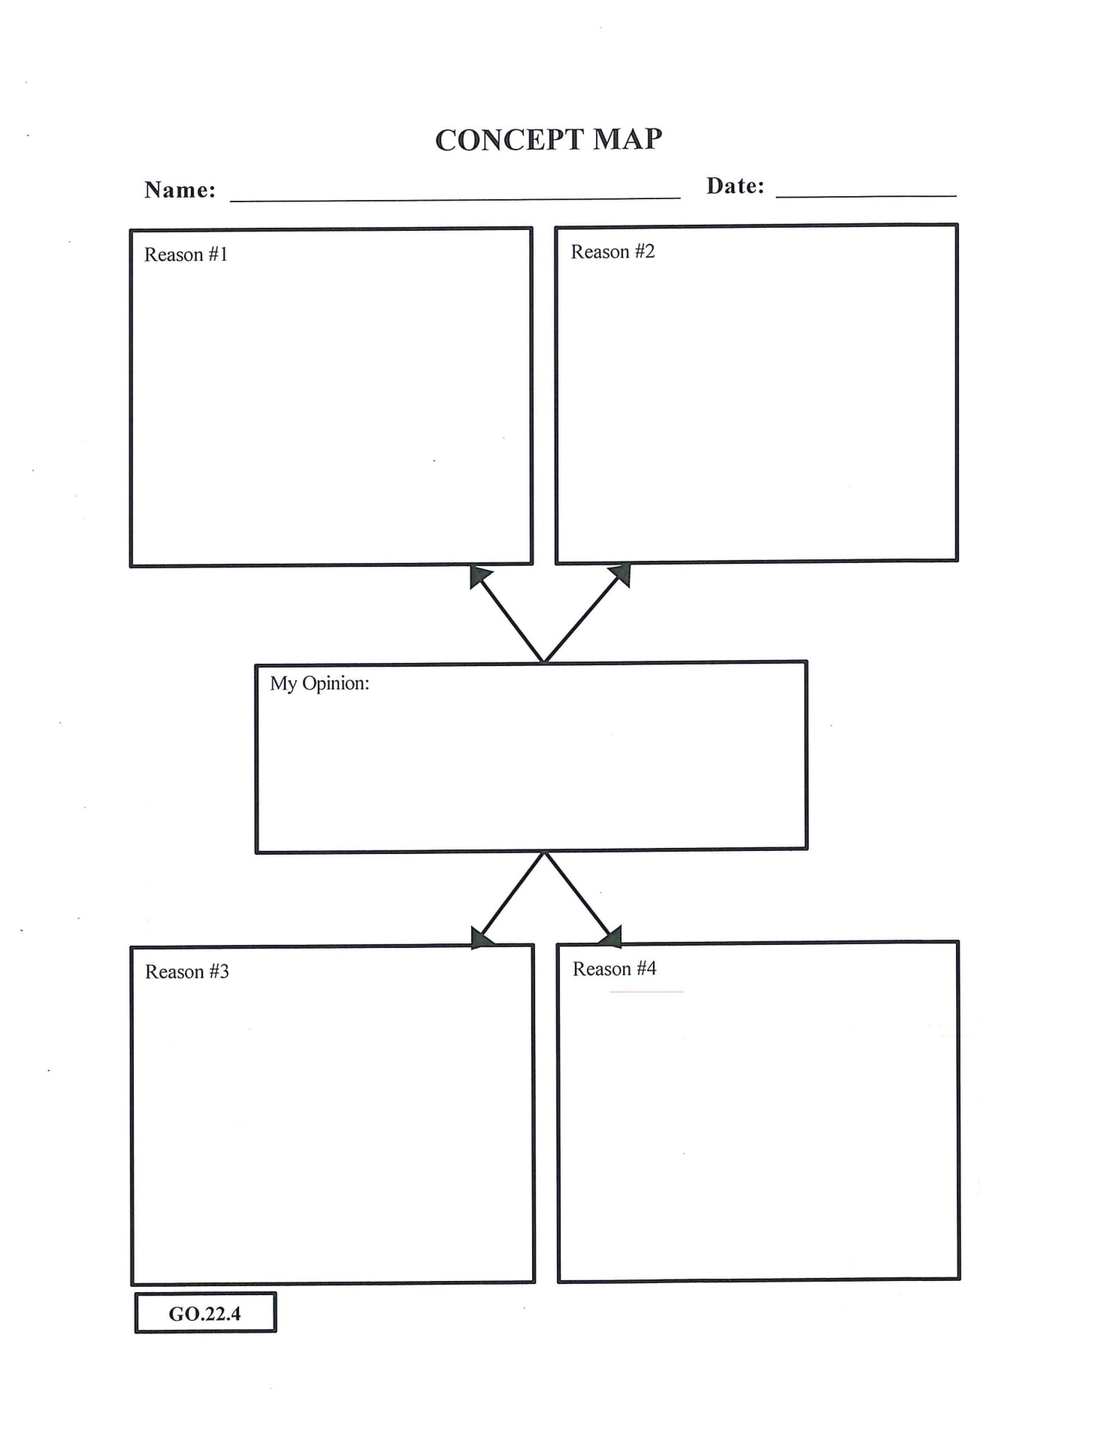

Return to your online lesson.
4.3 Identity Poem
Polanco’s “Identity” is an extended metaphor poem. Polanco tells us a lot about his character by simply describing this “weed” that he identifies himself with.
Now, it’s your turn to write an extended metaphor poem!
First, let’s find something you might identify yourself with…
Answer the following open-ended questions:
1.If I were a plant or animal, I’d be a _______________.
2.If I were a piece of furniture, I’d be a ____________.
3.If I were a color, I’d be ___________________________.
4.If I were a vehicle, I’d be a _______________________.
Now choose one!
On the following page, use the model of the poem to create your comparisons OR use your own form.
Note you do NOT need to use every single line as is. Just remember to use descriptive adjectives, strong verbs and unique similes.
Refer back to the poem in your course for help in writing yours.

Identity
Let them be as _______________________________________
always___________________________________________________________________
but ______________________________________________________ .
I’d rather be a ____________________________________ ,
______________________________________ like _________________________________
____________________________________________________________________ .
To have ___________________________________________ ,
to _____________________________________________________________ .
To be __________________________________________________________
or __________________________________________________________ .
I’d rather be _____________________________________ , and if
then __________________________________________________________ ,
then to be __________________________________________________________________
where ___________________________________________
by _____________________________________ .
I’d rather ________________________________________________
than _________________________________________ .
If I could _______________________________________________ ,
I’d rather be a ________________________________________ . (repeat first line)
Based on: http://englishlessoncollection.blogspot.com/2010/05/identity-poetry-activity.html.

4.4 Bio-Poem
Bio-Poem Step 1: Brainstorming ideas
1. List at least seven adjectives that you would use to describe yourself. ____________________________________________________________________________________
2. List three important relationships in your life (e.g., friend, brother, daughter, or nephew). _____________________________________________________________________________________
3. List five things that you love. _____________________________________________________________________________________
4. List five memories you have and describe how you felt at those times. _____________________________________________________________________________________ _____________________________________________________________________________________ _____________________________________________________________________________________ _____________________________________________________________________________________ _____________________________________________________________________________________
5. List five of your fears. _____________________________________________________________________________________ _____________________________________________________________________________________ _____________________________________________________________________________________ _____________________________________________________________________________________ _____________________________________________________________________________________
6. List three accomplishments. _____________________________________________________________________________________ _____________________________________________________________________________________ _____________________________________________________________________________________ Adapted from: Facing History and Ourselves and Memphis Public Schools. “Identity and Community: An Introduction to Sixth Grade Social Studies.” Copyright © 2008 by Facing History and Ourselves Foundation, Inc. http://www.facinghistory.org/resources/units/identity-community Example: Martin Proud, courageous, eloquent, wise Leader to millions Who loved nonviolence, god, and humanity Who felt outraged by hate and prejudice And who was inspired by acts of kindness Who gained greater dignity for his people And hoped everyone could leave in peace He lives in our hearts Luther King, Jr.
7. List five wishes or hopes. _____________________________________________________________________________________ _____________________________________________________________________________________ _____________________________________________________________________________________ _____________________________________________________________________________________ _____________________________________________________________________________________
8. Where do you live? _____________________________________________________________________________________
Step 2: Use your answers to the above questions to help you write your bio-poem. Use the example in our course and the The Bio-poem Structure below to write your poem.
(Line 1) First name
(Line 2) Three or four adjectives that describe you
(Line 3) Important relationship (e.g., daughter of . . . , friend of . . . )
(Line 4) Two or three things, people, or ideas that you love:
(Line 5) Three feelings you have experienced
(Line 6) Three fears you have experienced
(Line 7) Accomplishments (e.g., who won . . . who performed . . . who learned . . .)
(Line 8) Two or three things you want to see happen or want to experience
(Line 9) Your residence
(Line 10) Last name:
https://digitalcommons.trinity.edu/cgi/viewcontent.cgi?article=1253&context=educ_understandings

4.5 Haiku and Diamante
You can choose to write a Haiku or a Diamante poem. Be sure to follow the rules of the chosen form (number of lines, number of syllables, theme, etc.) Use your inspiration list in your first entry to get an idea.

Submit this writer’s notebook to your instructor now.

