Name:
Date:

Unit 3 ~ Writer’s Workshop Notebook

Student Instructions:
Complete the following learning guide as you work through the related lessons. You are required
to have this package completed BEFORE you go on to the next unit. Do your best. Ask your home facilitator for help as needed and contact your teacher if you have further questions. See below for the Learning Guide marking rubric.

Home Facilitator Instructions:
As soon as your student has completed a worksheet or two, please mark and go over the answers with him or her. Talk about sections where the student excelled and sections where the student had any difficulty. Students learn more if they can get feedback as they progress through the course.

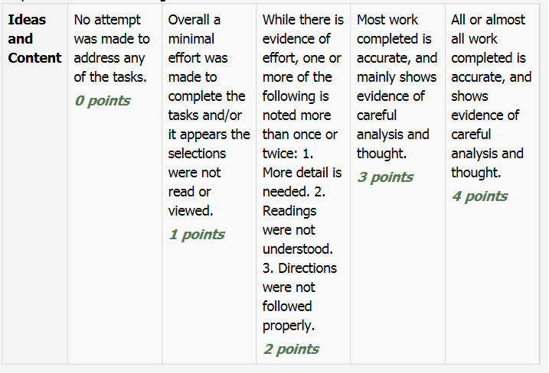
Note: While marking on a scale of 4 the total points will be out of 16.
Name:____________________________ Date:_____________________
3.1 Advertisements
Consider what you’ve learnt so far and take a moment to explore some ads on the internet, radio or TV. Once you’ve done so, complete the following chart, you can do so in point form:
Where do you see advertisements?
What makes an advertisement effective?
Who are the people that advertise?
What do advertisers want you to think or do?

Return to the online lesson book
3.2 Branding Tools
After having completed the quiz on branding tools and looking for important qualities of a logo or slogan, complete the chart.

Key Qualities of a Logo | Key Qualities of a Slogan

Return to the online lesson book.

3.3 Advertising Techniques
Complete the chart in point form note style:

Advertising Strategy | Summary Notes | Sample Advertisement | Target Audience
Ideal kids (or families)
Family Fun

Excitement

Star Power
Bandwagon
Scale
Put Downs
Facts and Figures
Repetition
Heart Strings
Sounds Good
Cartoon Characters
Weasel Words
Omission
Are You Cool Enough?

Return to the online lesson book.

3.4 Two Different Audiences
- Choose a product, service or issue to advertise.
- Decide on your two target audiences.
- Select your advertising technique(s) from 3.3
- Plan a strategy – deciding upon images, design, logos, slogans, text, etc.
You will not actually need to create the advertisement, the purpose of the task is to select the appropriate strategy for the appropriate audience and product.

Planning Notes
Product / Service / Issue:
Target Audience: | Target Audience:
Advertising Technique: | Advertising Technique:
Strategy Notes: | Strategy Notes:
Return to your online lesson book.

3.5 Advertising and Image
Time to write a reflection piece on the article you read. Discuss whether you agree or disagree with the author’s point of view in the article Be sure to give specific examples of ads to support your arguments.
____________________________________________________________________
____________________________________________________________________
____________________________________________________________________
____________________________________________________________________
____________________________________________________________________
____________________________________________________________________
____________________________________________________________________
____________________________________________________________________
____________________________________________________________________
____________________________________________________________________
____________________________________________________________________
____________________________________________________________________
____________________________________________________________________
____________________________________________________________________
____________________________________________________________________
____________________________________________________________________
____________________________________________________________________
____________________________________________________________________
____________________________________________________________________
____________________________________________________________________
Return to your online lesson book.

3.6 Create your Own Product
You are in charge of designing an advertisement for a new product you invented (school appropriate). Fill out the information below as part of your planning and then create the advertisement.
Step 1: Product Name
____________________________________________________________________
Step 2: Product Company
____________________________________________________________________
Step 3: Product description: What exactly is your product? What does it do? What are the benefits?
____________________________________________________________________
____________________________________________________________________
____________________________________________________________________
____________________________________________________________________
____________________________________________________________________
____________________________________________________________________
____________________________________________________________________
Step 4: Who is the target audience?
____________________________________________________________________
____________________________________________________________________
Step 5: What pictures and/or images will you have on your ad? Why will you include those?
____________________________________________________________________
____________________________________________________________________
____________________________________________________________________
____________________________________________________________________
____________________________________________________________________
____________________________________________________________________
____________________________________________________________________
Step 6: What advertising techniques will you use? Explain. You must use at least two.
____________________________________________________________________
____________________________________________________________________
____________________________________________________________________
____________________________________________________________________
____________________________________________________________________
____________________________________________________________________
____________________________________________________________________
Step 7: What is the slogan or jingle for this product? You only have to have one or the other.
____________________________________________________________________
____________________________________________________________________
____________________________________________________________________
____________________________________________________________________
____________________________________________________________________
____________________________________________________________________
____________________________________________________________________
Once you’ve completed this planning sheet and received feedback from your teacher you can begin creating your actual advertisement. You can draw it or create it digitally.

Submit this writer’s notebook to your instructor now.

