Name:
Date:

Unit 2 ~ Writer’s Workshop Notebook

Student Instructions:
Complete the following learning guide as you work through the related lessons. You are required
to have this package completed BEFORE you go on to the next unit. Do your best. Ask your home facilitator for help as needed and contact your teacher if you have further questions. See below for the Learning Guide marking rubric.

Home Facilitator Instructions:
As soon as your student has completed a worksheet or two, please mark and go over the answers with him or her. Talk about sections where the student excelled and sections where the student had any difficulty. Students learn more if they can get feedback as they progress through the course.

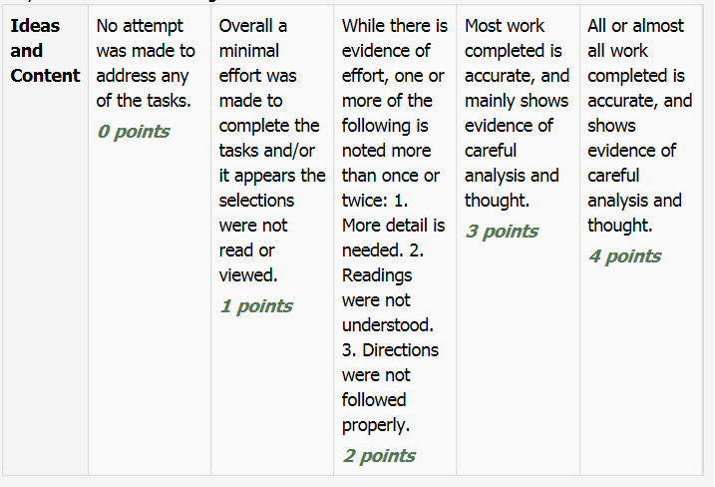
Note: While marking on a scale of 4 the total points will be out of 16.
Name:____________________________ Date:_________________________

2.1 Arguments For & Against
The topic I have chosen is: ___________________________________________________________

___________________________________________________________

Arguments For | Arguments Against

My position is ___________________________(list for or against).

Return to the online lesson book.

Name:____________________________ Date:_________________________

2.2 Concept Map

Reason #2
Reason #1

Reason #3
Reason #4 Opposing Argument

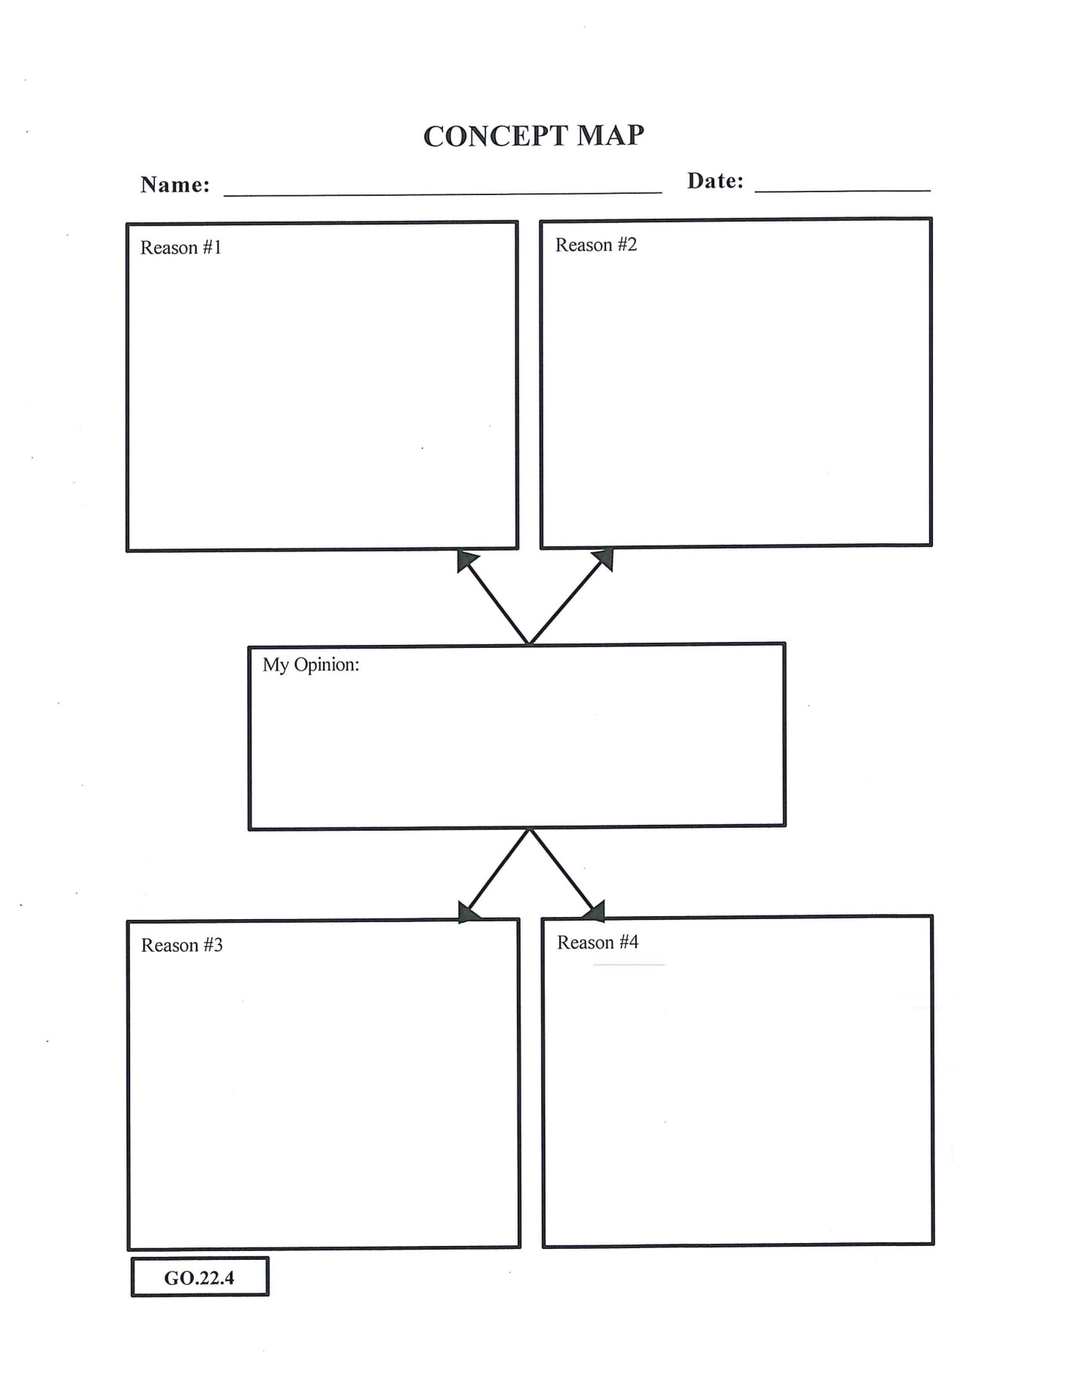

Return to your online lesson.
2.3 Persuasive Planning
Reason#1 Topic Sentence:
____________________________________________________________________
____________________________________________________________________
Supporting Details:
- _________________________________________________________________
____________________________________________________________________
- __________________________________________________________________
____________________________________________________________________
- __________________________________________________________________
____________________________________________________________________

Reason#2 Topic Sentence:
____________________________________________________________________
____________________________________________________________________
Supporting Details:
- _________________________________________________________________
____________________________________________________________________
- __________________________________________________________________
____________________________________________________________________
- __________________________________________________________________
____________________________________________________________________

Reason#3 Topic Sentence:
____________________________________________________________________
____________________________________________________________________
Supporting Details:
- _________________________________________________________________
____________________________________________________________________
- __________________________________________________________________
____________________________________________________________________
- __________________________________________________________________
____________________________________________________________________

Reason#4 (Opposing Argument) Topic Sentence:
____________________________________________________________________
____________________________________________________________________
Supporting Details:
1._________________________________________________________________
____________________________________________________________________
- __________________________________________________________________
____________________________________________________________________
- __________________________________________________________________
____________________________________________________________________

Return to your online lesson book.

2.4 Opening
Write the first draft of your opening statement for your persuasive essay.
Step 1: Write a hook sentence to grab your reader’s attention.
____________________________________________________________________
____________________________________________________________________
Step 2: Introduce your topic by telling the who, what, and why you’re writing.
____________________________________________________________________
____________________________________________________________________
____________________________________________________________________
____________________________________________________________________
____________________________________________________________________
____________________________________________________________________
____________________________________________________________________
Step 3: State your claim by answering the question, “What are you persuading your audience to do/think?”
____________________________________________________________________
____________________________________________________________________
____________________________________________________________________
____________________________________________________________________
____________________________________________________________________
____________________________________________________________________
____________________________________________________________________

Return to your online lesson book.
2.5 Conclusion
Write the first draft of your concluding statement for your persuasive essay.
Step 1: Restate your claim.
____________________________________________________________________
____________________________________________________________________
Step 2: Be sure to include your 3 main reasons, using different wording than in the body of your essay.
____________________________________________________________________
____________________________________________________________________
____________________________________________________________________
____________________________________________________________________
____________________________________________________________________
____________________________________________________________________
____________________________________________________________________
Step 3: Conclude with an action point.
____________________________________________________________________
____________________________________________________________________
____________________________________________________________________
____________________________________________________________________
____________________________________________________________________
____________________________________________________________________
____________________________________________________________________

Submit this writer’s notebook to your instructor now.

