Name:
Date:

Unit 1 ~ Writer’s Workshop Notebook

Student Instructions:
Complete the following learning guide as you work through the related lessons. You are required
to have this package completed BEFORE you go on to the next unit. Do your best. Ask your home facilitator for help as needed and contact your teacher if you have further questions. See below for the Learning Guide marking rubric.

Home Facilitator Instructions:
As soon as your student has completed a worksheet or two, please mark and go over the answers with him or her. Talk about sections where the student excelled and sections where the student had any difficulty. Students learn more if they can get feedback as they progress through the course.

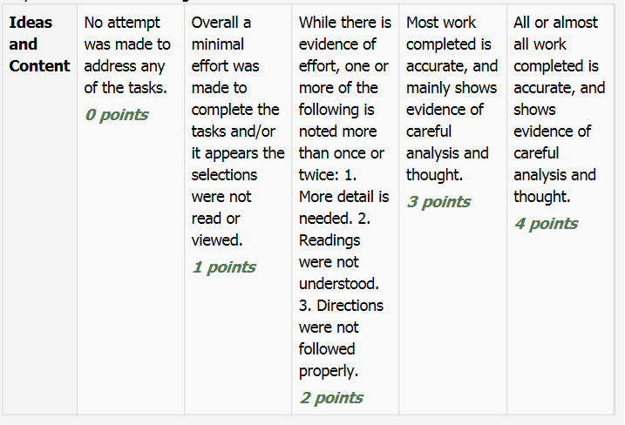
Note: While marking on a scale of 4 the total points will be out of 16.
Name:____________________________ Date:_________________________

1.1 Story Types
In the middle column, identify a short story, book, or movie you have seen or read that matches each story type listed. Explain the reasons for each choice in the third column.
Here's an example:
Story type: Adventure Title: Hatchet
Characteristics: the main character gets stranded in the wilderness when his plane crashes; he has to overcome many obstacles to survive; in just about every chapter he faces a new challenge

Story Type | Title | Characteristics
Adventure

Fantasy

Folk Tale

Historical
Fiction

Horror

Mystery

Realistic
Fiction

Science
Fiction

What story type will your narrative be? ________________________________
Return to the online lesson book.

Name:____________________________ Date:_________________________

1.2 Setting
Where will your story take place? Will it be in the past, present, or future? Will it be set in another country, in an imaginary world, or in your own backyard? Will it be happy, scary, or exciting? Describe this setting in the space provided.
This assignment can be done as point form notes, paragraphs (see example), a web outline, drawing with captions, or another form of your choice.

Example:
The story takes place in Nepal and in the lower regions of Mount Everest. It is quite muddy at the bottom and kind of like a jungle. As they climb, the air gets thinner and colder. The mountain is covered with snow and ice. There is a lot of fog making it hard for the climbers to see where they are going at times. The mountain is very steep in places

Return to your online lesson book.

1.3 Characters
Think of three main characters for your story. Describe how each of your characters looks, what their likes and dislikes are, and any strange or special behaviours they might have. An example is provided for you.

Example:
Character: | Sarah Mulligan
Description: | Sarah is a fourteen-year-old girl from Alberta. She has straight brown hair and brown eyes, and is very strong and fit. She likes mountain climbing and trekking and travels a lot with her parents to do this. Sarah likes the adventure but sometimes wishes she could stay in one place and be a normal kid who just hangs out with her friends.

Return to your online lesson book.

1.4 Plot
What will the key events in your story be? How will the conflict be overcome, or will it?
Outline the plot of your story in point form, a web, or in short paragraphs like in the example below. Make sure you have a believable situation, rising action with an interesting conflict, a climax that will grab the reader, falling action, and a conclusion that ties up all the loose ends.

Opening/Situation/Introduction:

Rising Action

Climax

Falling Action

Conclusion/Resolution

Return to your online lesson book.

1.5 Theme
What is the deeper message you want to get across to the readers of your story? What will make your story meaningful to these people? Describe in detail your bravery theme for your story. In a sentence or two explain why you chose the theme. Two examples are provided for you.
Examples
1. Nature is a powerful force that you must respect if you hope to survive. – I have chosen this theme because climbing Mount Everest is a dangerous thing to do. Trekkers are at a high elevation and the weather can change very quickly. There are many dangers. You have to be prepared and accept that nature is more powerful than you are
2. People can overcome many obstacles if they stay positive and work hard. – I have chosen this theme because climbing Mount Everest is a dangerous thing to do. Trekkers are at a high elevation and the weather can change very quickly. There are many dangers. You have to be prepared and accept that nature is more powerful than you are.

Submit this writer’s notebook to your instructor now.

