Name:
Date:

Unit 4 ~ Learning Guide

Student Instructions:
Complete the following learning guide as you work through the related lessons. You are required
to have this package completed BEFORE you go on to the next unit. Do your best. Ask your home facilitator for help as needed and contact your teacher if you have further questions. See below for the Learning Guide marking rubric.

Home Facilitator Instructions:
As soon as your student has completed a worksheet or two, please mark and go over the answers with him or her. Talk about sections where the student excelled and sections where the student had any difficulty. Students learn more if they can get feedback as they progress through the course.

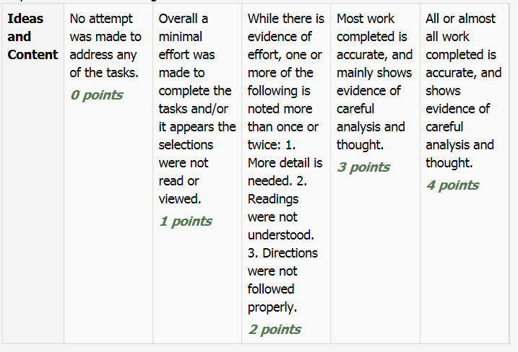
Note: While marking on a scale of 4 the total points will be out of 16.

4.1 Totem Poles
Reflection
1. Take a moment to reflect on ways in which your culture is reflected in your identity. How does your culture shape your celebrations, your family history, your daily life? What items or beliefs are important for connecting you to your culture?

___________________________________________________________________________ ___________________________________________________________________________ ___________________________________________________________________________ ___________________________________________________________________________ ___________________________________________________________________________ ___________________________________________________________________________ ___________________________________________________________________________ ___________________________________________________________________________ ___________________________________________________________________________ ___________________________________________________________________________ ___________________________________________________________________________ ___________________________________________________________________________ ___________________________________________________________________________ ___________________________________________________________________________ ___________________________________________________________________________ ___________________________________________________________________________ ___________________________________________________________________________ ___________________________________________________________________________ ___________________________________________________________________________

Read and Respond
Read the following text (from https://indigenousfoundations.arts.ubc.ca/totem_poles/):

In 1872, Chief G’psgolox commissioned artists Hemzid and Wakas to carve a pole in memory of the chief’s deceased wife and children. Starting in the early 1920s, the federal government adopted a policy of salvage anthropology and, fearing the decline of Indigenous art, began to buy out totem poles from communities living along the Skeena River. In 1927, Iver Fougner, an Indian Agent in Bella Coola, wrote to the Department of Indian Affairs asking permission for the Swedish Consul of British Columbia to purchase the G’psgolox Pole.1 One day in 1929, the pole was severed and taken from the Haisla village of Misk’usa while the villagers were away on a fishing trip.2 The pole was then shipped to Sweden, where it remained in storage until 1980, when it was finally put on display at the national Museum of Ethnography in Stockholm.

Eventually, the Haisla learned of the pole’s whereabouts in 1991, and began the long journey of repatriating the pole. The Haisla and the museum negotiated a plan for repatriation: the museum agreed to return the pole, and the Haisla would carve a replacement. Finally, in April 2006, the pole returned to Vancouver. On July 1, 2006, the Haisla officially welcomed the pole home to Kitimat. It was the first pole in Canada to be repatriated from overseas. Louisa Smith, a spokesperson for the Haisla chief, summed up the emotion of the day: “The repatriation of the G’psgolox totem pole has been a journey of a hundred years and thousands of miles…Our children and future generations will be able to see, touch and feel a piece of their history, reclaimed by a nation against all odds.”3

This story is documented by director Gil Cardinal in a National Film Board (NFB) documentary entitled Totem: The Return of the G’psgolox Pole. You can view the film in its entirety on the NFB website (link below).

1 “G’psgolox pole returns home after 77 years, First totem ever to be repatriated from overseas,” Ecotrust Canada, http://www.ecotrust.ca/g%E2%80%99psgolox-pole-returns-home-after-77-years-first-totem-ever-be-repatriated-oversea (accessed 13 January, 2011).
2 “Totem: The Return of the G’psgolox Pole- Film Description,” National Film Board of Canada, http://www.onf-nfb.gc.ca/eng/collection/film/?id=51162 (accessed 13 January, 2011).
3 Ecotrust Canada.

In what ways would “salvage anthropology” affect the community from which items have been removed? Despite the time that had passed, why was it important for the Haisla to repatriate their stolen mortuary pole?
__________________________________________________________________________________________________________________________________________________________________________________________________________________________________________________________________________________________________________________________________________________________________________________________________________________________________________________________________________________________________________________________________________________________________________________________________________________________________________________________________________________________________________________________________________________________________________________________________________________________________________________________________________________________________________________________________________________________________________________________________________________________________________________________________________________________________________________________________________________________________________________________________________________________________________________________________________________________________________________________________________________________________________________________________________________________________________________________________________________________________________________________________________
Extension: Watch the NFB documentary Totem: The Return of the G’psgolox Pole.

Return to the online lesson book.

4.2 Poem: I Lost My Talk
Vocabulary
A. Find the definition for the following words used in the poem:
1. snatched___________________________________________________________________________
_________________________________________________________________________________
2. ballad________________________________________________________________________
_________________________________________________________________________________
3. scarmbled_______________________________________________________________________
_________________________________________________________________________________
4. powerful_________________________________________________________________________
_________________________________________________________________________________
B. What do you think the author means by “talk” and “your way”? Think about one of the main differences between Western culture versus First Peoples’ culture when answering.

C. What do you think the poet means by “scrambled ballad”?

Return to your online lesson book.

4.3 Poem: Amphibians
Finding Meaning in Structure

An s we r t h e f o l l o wi n g q u e s t i o n s:

- This poem is very carefully structured as the author compares immigrants to amphibians. Explain how the content of the poem is organized to do this.

- Using one or two specific examples from the poem, explain in your own words how this comparison is effective and perhaps helped you to understand a little better the journey of an immigrant.

- Consider the line “Their colors brighten, camouflage” that is talking literally about amphibians. What do you think this is saying about immigrants and their new life?

Return to your online lesson book.
4.4 Who Am I? (On the Outside)
Generating Ideas

Who Am I?

Return to your online lesson book.
4.5 Who Am I? (On the Inside)
Generating Ideas

Who Am I?

Return to your online lesson book.

4.6 Poem: Victory
Activity:
After reading the poem carefully, consider what you learn about the author’s identity. Refer back to the lists of outside and inside identifiers that you used in the previous ideas.

Note that some may be directly stated but several may be inferred from his actions or indirect evidence.

List five things that are part of his identity. For each supply a line from the poem as evidence including the line number in brackets.

Example:

Twelve year old boy
“When I was twelve, I shoplifted a pair”(1).

1.

2..

3.

4.

5.

Return to your online lesson book.

4.7 Excerpt: The Face on the Milk Carton

1. In a well written paragraph describe what you know about Janie’s identity. What does she look like? Age? Family? Etc.

2. Part of anyone’s identity is her name. How does Janie feel about her name and how it identifies her? What would she rather change it to and why?

3. Near the end of the excerpt, Jane finds something out that will make reconsider everything she knows about herself. What does she realize and what memory confirms it?

Submit your completed learning guide to your instructor.

