Name:
Date:

Unit 3 ~ Learning Guide

Student Instructions:
Complete the following learning guide as you work through the related lessons. You are required
to have this package completed BEFORE you go on to the next unit. Do your best. Ask your home facilitator for help as needed and contact your teacher if you have further questions. See below for the Learning Guide marking rubric.

Home Facilitator Instructions:
As soon as your student has completed a worksheet or two, please mark and go over the answers with him or her. Talk about sections where the student excelled and sections where the student had any difficulty. Students learn more if they can get feedback as they progress through the course.

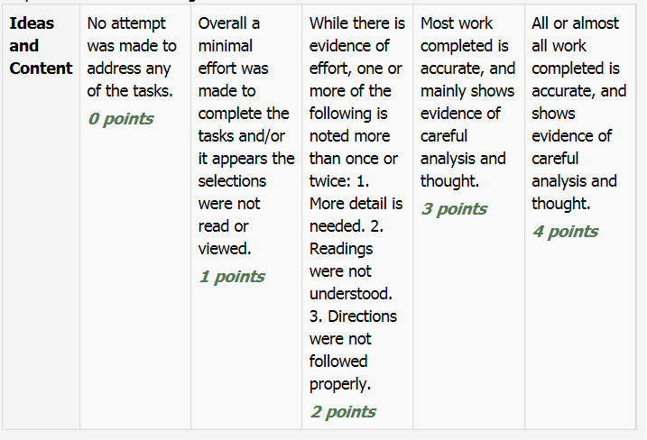
Note: While marking on a scale of 4 the total points will be out of 16.
Name:____________________________ Date:_________________________

3.1 How Do YOU Define Yourself
Reading for Information

- What difficulties did she face in life? How was she treated in school?
____________________________________________________________________________________________________________________________________________________________________________________________________________________________________________________________
- What are some of Lizzie’s positive traits (perseverance, resilience, positive attitude, focus on what is important in life, etc.) that contribute to her positive self-concept?
____________________________________________________________________________________________________________________________________________________________________________________________________________________________________________________________
- What about her do you most admire?
____________________________________________________________________________________________________________________________________________________________________________________________________________________________________________________________
- How might her positive traits inspire and help others?
____________________________________________________________________________________________________________________________________________________________________________________________________________________________________________________________
- How does Lizzie demonstrate that “beauty is on the inside”?
____________________________________________________________________________________________________________________________________________________________________________________________________________________________________________________________

- Who in her life supported her, and how did this help build her self-esteem?
____________________________________________________________________________________________________________________________________________________________________________________________________________________________________________________________
- If she were a student at your school, how could the school community support her?
____________________________________________________________________________________________________________________________________________________________________________________________________________________________________________________________

Return to the online lesson book.

3.2 Personal Inventory
School Subjects
- I like ___________________________________________________________________.
- I do not like _____________________________________________________________.
- I am good at ____________________________________________________________.
- I am not good at _________________________________________________________.
- I am good at this subject, but I do not like it: ___________________________________.
- I am not good at this subject, but I like it: ______________________________________.
Activities
- I like ___________________________________________________________________.
- I do not like _____________________________________________________________.
- I am good at _____________________________________________________________.
- I am not good at __________________________________________________________.
- I am good at this activity, but I do not like it:_____________________________________.
- I am not good at this activity, but I like it: _______________________________________.
- I prefer being involved in individual activities _____ or group activities ___. (Check one.)
Relationships with Friends and Adults (Write yes for the statements that apply to you.)
- I am generally well liked: ____________.
- I am generally not well liked: ___________.
- I have a group of friends: ________.
- I prefer having one or two friends: _______.
- I am a leader: ___________.
- I am a follower: _________.
- I prefer people who like the same things I like: ___________.
- I prefer people who like different things: _____________.
- I have the support of significant adults in my life: __________________.
- I have the support of a group of peers: ______________________.
Food Preferences
- I like to eat ______________________________________________________________.
- I do not like to eat ________________________________________________________.
- I do ____ do not _____ eat a balanced diet. (Check one.)
Relaxing
- I relax by _______________________________________________________________.
- I like relaxing alone _____ or with other people ____. (Check one.)
Return to your online lesson book.

3.3 Positive Thought Strategies

Create your positive thought strategies list. Choose 3-6 strategies that will work best for you:

- _________________________________________________________________________________

_________________________________________________________________________________

- _________________________________________________________________________________

_________________________________________________________________________________

- _________________________________________________________________________________

_________________________________________________________________________________

- _________________________________________________________________________________

_________________________________________________________________________________

- _________________________________________________________________________________

_________________________________________________________________________________

- _________________________________________________________________________________

_________________________________________________________________________________

Return to your online lesson book.

3.4 How to Stop Cyberbullying
Literary Elements
A. Fill-in the chart by identifying the main ideas and ways of dealing with cyber bullying as discussed during the video:

How to handle Cyberbullying.

Return to your online lesson book.

3.5 The Sneetches
Making Inferences
Answer the following questions:
How do the Star-Belly Sneetches look? How do the Plain-Belly Sneetches look?
______________________________________________
______________________________________________
______________________________________________
______________________________________________
______________________________________________
How is the language different for Plain and Star-bellied Sneetches?
______________________________________________
______________________________________________
______________________________________________
______________________________________________
______________________________________________

Do you think the “star” on their bellies makes them feel differently about themselves? Why or why not?
______________________________________________
______________________________________________
______________________________________________
______________________________________________
______________________________________________

What kinds of things do we use as “stars” that make people feel special or inferior to others?
______________________________________________
______________________________________________
______________________________________________
______________________________________________
______________________________________________

The Sneetches all want to alter themselves in some way. Explain how this is similar to today’s society. Give some examples.
______________________________________________
______________________________________________
______________________________________________
______________________________________________
______________________________________________

List 3 actions you will take to help everyone feel like they belong and are valued.
______________________________________________
______________________________________________
______________________________________________
______________________________________________
______________________________________________
Literary Devices
What point of view is the story written from?
_____________________________________________

Find an example of symbolism in the story and identify what the author is trying to tell us.
______________________________________________
______________________________________________
______________________________________________
______________________________________________
______________________________________________

Find an example of foreshadowing in the story and identify what the author is trying to tell us.
______________________________________________
______________________________________________
______________________________________________
______________________________________________
______________________________________________

Return to your online lesson book.
3.6 Deeper Thinking
Drawing Conclusions
Answer the following questions:
Write a definition for self-image.
______________________________________________
______________________________________________
______________________________________________
______________________________________________
______________________________________________
What mental pictures to you have of yourself? How do others perceive you? Are these perceptions similar?
______________________________________________
______________________________________________
______________________________________________
______________________________________________
______________________________________________
How does your self-image affect that way you act and how others see and treat you?
______________________________________________
______________________________________________
______________________________________________
______________________________________________
______________________________________________
Can you self-image change? What kinds of things can you do to improve it?
______________________________________________
______________________________________________
______________________________________________
______________________________________________
______________________________________________
Submit this learning guide to your instructor now.

