Name:
Date:

Unit 2 ~ Learning Guide

Student Instructions:
Complete the following learning guide as you work through the related lessons. You are required
to have this package completed BEFORE you go on to the next unit. Do your best. Ask your home facilitator for help as needed and contact your teacher if you have further questions. See below for the Learning Guide marking rubric.

Home Facilitator Instructions:
As soon as your student has completed a worksheet or two, please mark and go over the answers with him or her. Talk about sections where the student excelled and sections where the student had any difficulty. Students learn more if they can get feedback as they progress through the course.

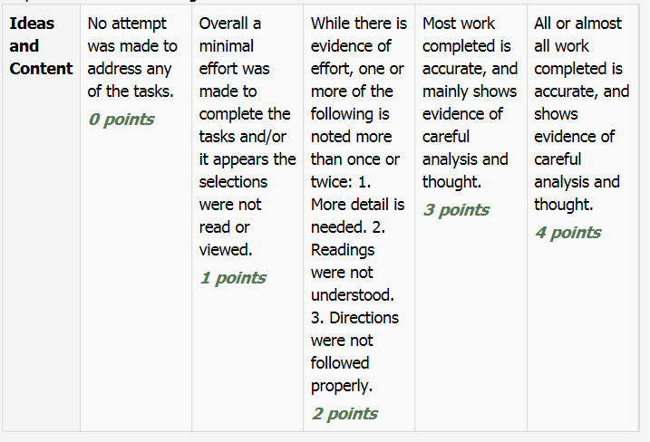
Note: While marking on a scale of 4 the total points will be out of 16
2.1 Legends

Reading for Information

- In your own words explain how Napi caused the rock to break into two.

Return to the online lesson book.

2.2 The Natural World -Stewardship and Gratitude
What are the main ideas?
- For each paragraph IN ONE SENTENCE summarize the main idea.
Paragraph | Main Idea
1.
2.
3.
4.

- Stewardship is mentioned in the first paragraph. In your own words define what that means (you may need to look it up) and then give an example in your community of how stewardship of the land is happening OR where it needs to be improved.

Return to your online lesson book
2.3 Poem: Nature
An s we r t h e f o l l o wi n g q u e s t i o n s :

1. Why do you think H.D. Carberry wrote the poem?
_________________________________________________________________________________
_________________________________________________________________________________
2. List three words related to nature. i)________________________________________________________________________________
ii)________________________________________________________________________________
iii)________________________________________________________________________________
3. Which line in the poem ‘Nature’ suggests the sense of smell? _________________________________________________________________________________
_________________________________________________________________________________
4. Based on your knowledge of the poem ‘Nature’, describe a theme in the poem. _________________________________________________________________________________
_________________________________________________________________________________
_________________________________________________________________________________
_________________________________________________________________________________
_________________________________________________________________________________
_________________________________________________________________________________

Return to your online lesson book.

2.4 Informational Writing

- Fill in a brief outline to note how this essay is organized:

Main idea:

Supporting Idea 1:

Supporting Idea 2:

Supporting Idea 3:

Supporting Idea 4:

- There are many lessons to be learned from nature. Think of two things that happen in nature that can teach us how to live our own lives.

a.

b.

Return to your online lesson book.

2.5 Nature Journaling
Observing and Recording Details
Find a place in nature that is close to you where you can sit and observe without being disturbed. Use all your senses to observe the natural world surrounding this particular spot.
Close your eyes and focus on your surroundings for a few minutes. Try to separate yourself from civilization. What do you hear? Smell? Taste? Feel? • Jot down your feelings, emotions, and sensations. What are your attitudes toward your present surroundings? What connections do you feel to this particular spot? • Observe cloud patterns. Observe wildlife, including insects. Observe a tree, a bush, or a plant. • Illustrate what you see. • Listen to the wind and record what it sounds like. Try illustrating the wind. Be specific. Use an analogy to compare what you see.
You complete your journal using point form, sketches, text, etc. Use the blank page that follows:

2.6 Sharing Stories
Responding to Text
Most of the selections you have just read or viewed all look at different perspectives on nature.
Think about how these shared stories have impacted your perspective on nature. Write a journal type entry with regards to any new understandings you have reached as a result of what you have just read/viewed in this unit.

Submit this learning guide to your instructor now. The dropbox is called Learning Guide Unit 2 Dropbox.

