Name: Date:

Unit 1 ~ Learning Guide

Student Instructions:
Complete the following learning guide as you work through the related lessons. You are required
to have this package completed BEFORE you go on to the next unit. Do your best. Ask your
home facilitator for help as needed and contact your teacher if you have further questions. See below for the Learning Guide marking rubric.

Home Facilitator Instructions:
As soon as your student has completed a worksheet or two, please mark and go over the answers with him or her. Talk about sections where the student excelled and sections where the student had any difficulty. Students learn more if they can get feedback as they progress through the course.

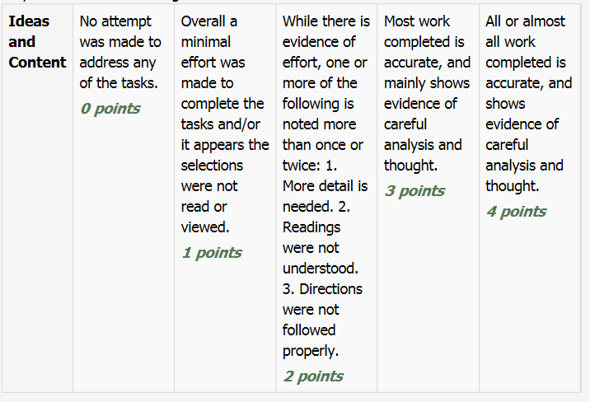
Note: While marking on a scale of 4 the total points will be out of 16.

1.1 Tedtalk: What It Means to be Brave

Reading for Information

A n s w e r t h e f o l l o w i n g q u e s t i o n s :

1. In a few words explain specifically how the author gets your attention at the beginning.

2. She suggests looking at bravery in a fresh way. How?

3. She suggests that we can uncover what it takes to tap into that illusive "want" and be the brave leader you were born to be. How do we do this?

4. List some “tools” she refers to that help us act bravely.

5. What commitment does the author make in her conclusion that allows her to make an impact in the world? She asks us “What are you fighting for?” Why is this an important question to answer?

Return to the online lesson book.

1.2 Poem: A Poem to the Brave

Vocabulary
A. Fi nd t he de f i ni t i on f or t he
f ol l ow i ng w or ds u s e d i n t he poe m :

1. trenches _____________________________________________________________________________

_______________________________________________________________________________________

2. lapsed _______________________________________________________________________________

_______________________________________________________________________________________

3. eternal _______________________________________________________________________________

_______________________________________________________________________________________

4. shell-shocked __________________________________________________________________________

_______________________________________________________________________________________

4. memorials ____________________________________________________________________________

_______________________________________________________________________________________

5.mourners _____________________________________________________________________________

_______________________________________________________________________________________

6. Great War____________________________________________________________________________

_______________________________________________________________________________________

B. In your own words explain 3 actions of bravery described in the poem.

_______________________________________________________________________________________

_______________________________________________________________________________________

Return to your online lesson book.

1.3 YouTube Clip: A Heroic Nanny

Summarizing

A n s w e r t h e f o l l o w i n g q u e s t i o n s :

A. Do you think bravery is something we are born with or learn to be?

B. If she were to write down her experience into a story, list in point form a few sensory details that she might include (sight, sound, taste, touch, smell) to convey her bravery and feelings.

Return to your online lesson book.

1.4 Short Story: Rikki Tikki Tavi

Literary Elements

A . I n th e c h ar t b el o w , define the literary element, l i st an e x am p l e fr o m th e t ext "Rikki Tikki Tavi" and describe what the literary element reveals or its purpose.

Definition of Literary Element | Example from the Text | What it Reveals; Purpose/effect
Metaphor

Similes

Personification

Onomatopoeia

Return to your online lesson book.

1.5 Short Story: Rikki Tikki Tavi

Characterization

Com pl e t e t he f ol l ow i ng c ha r t : R ef er to th e
l es so n o n ch ar ac ter t r ai ts yo u j u st
w a tch ed . L i st e xa m p l es o f ac ti o n s an d th e
c or r e s pon di ng t r a i t s .

R i kk i ’ s act i o n s | C h aract er T rai t
1.
2.
3.
4.
5.

Return to your online lesson book.

1.6 Sharing Stories

Responding to Text

1. In p o in t f o rm lis t 3 - 5 w a ys th at t h e au th o r o r m a in ch ar a ct e r s d em o n str at ed b r av er y .
2. De s c r i be y our de f i ni t i on of br a v e r y.

S ubm i t t hi s learni ng gui de t o y our
i ns t r uc t or now . The dropbox is called Learning Guide Unit 1 Dropbox.

