Name:

Date:

**Career Education – Goal Setting**

**Assignment 6.0**

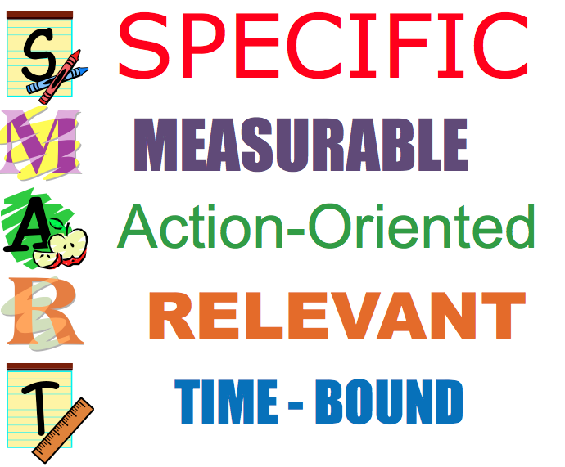*To show that you can reach the learning targets of this lesson, you will be using the SMART goal format to set one short-term and one long-term goal. You will plan your goal, think about obstacles and how you will overcome them, and have a way to tell that you have achieved each goal. Creating goals that are SMART make them easier to achieve.*

*You may write your answers in this document or make an audio or video recording to share your responses. You could even have your home facilitator interview you in a “talk show” format but be sure to plan out your responses first.*

**Short-term Goal**

1. Goal Statement: (State your goal in SMART terms. S- Specific, M-Measurable, A- Action-Oriented, R – Relevant, T-Time-Bound)

2. Action Plan: (Give steps or plan out a schedule of activities to reach your goal. Include people or other supports that will help you to be successful.)

3. List two or more possible obstacles and solutions:

(i).

(ii).

4. Keep track of your progress for a few days. If you made progress toward your goal, describe it here:

**Long-term Goal**

1. Goal Statement: (State your goal in SMART terms. S- Specific, M-Measurable, A- Action-Oriented, R – Relevant, T-Time-Bound)

2. Action Plan: (Give steps or plan out a schedule of activities to reach your goal. Include people or other supports that will help you to be successful.)

3. List two or more possible obstacles and solutions:

(i).

(ii).

Your teacher may ask about your success in working toward this goal later in the school year.