

1.5 Career Education

Values Exercise
Name:

Instructions:
Use the resources in the book 1.5 and the table below to carefully evaluate what is most important to you!
- Accountability  - Achievement  - Adventure  - Ambition  - Assertiveness  - Attractiveness  - Awareness  - Beauty  - Being the Best  - Belonging  - Caring  - Charity  - Chastity  - Cheerfulness  - Citizenship  - Commitment  - Communication  - Community  Compassion  - Competitiveness  - Contribution  - Control  - Cooperation  - Courage  - Courtesy  - Creativity  - Curiosity  - Decisiveness  - Dependability  - Determination  - Discipline  - Diversity | - Education  - Empathy  - Enthusiasm  - Entrepreneurialism  - Excellence  - Fairness  - Faith  - Family  - Fitness  - Forgiveness  - Friendship  - Fun  - Generosity  - Hard Work  - Health  - Helpfulness  - Honesty  - Honor  - Humility  - Humor  - Independence  - Integrity  - Intelligence  - Intimacy  - Justice  - Kindness  - Leadership  - Love  - Loyalty | - Making a difference  - Open-mindedness  - Optimism  - Order/Organization  - Passion  - Patriotism  - Perseverance  - Popularity  - Self-control  - Self-reliance  - Service  - Simplicity  - Spirituality  - Spontaneity  - Success  - Teamwork  - Thoughtfulness  - Thrift  - Trust  - Truth  - Recognition  - Reliability  - Resilience  - Resourcefulness  - Respect  - Risk-taking  - Wealth  - Winning  - Wisdom
1. Go through the list of values outlined here and try to identify your top 20. Maybe use a highlighter from the font menu or an asterisk or….

Revisit the link here from 1.5 Exploring Values:
2a. Identify the two Pitfalls introduced on this site that people make with finding their values?

b. Give an example of each, either from personal experience, or something you’ve witnessed others doing. (Example: Many people adapt the political values of their parents. My parents are strong conservatives; therefore, I am a conservative…)

Make sure you have viewed the video in 1.5 and in the above “The HJOT” link called My Identity Puzzle
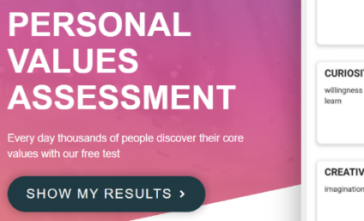
3. Use a different colour or other method to narrow your list above to a top 10.
4. Now list the 5 values you consider to be the most important at this point in your life (remember, there is a good chance they will change as you do). Use the other link shared in 1.5 (Personal Values Assessment) to help you with your top five). Then come up with some ideas of how you can take action, live up to, demonstrate, fulfill, etc. those values.
Top 5 Values | Action you can take to demonstrate or live up to the value:
1
2
3
4
5

