Name:

Date:

**Physical and Health Education 7 - Assignment 2.5 – Influences and Consequences**

**Assessment per Rubric.**

**Assignment:**

1. Give and explain three influences on or reasons some teenagers start using cigarettes or alcohol.

*Reason 1:

*Reason 2:

*Reason 3:

2. You have been invited to a party with some of the more popular players from your soccer team. You know some of them drink alcohol. You go to the party and, as you expected, people are offering you drinks of alcohol. How will thinking of the following people/concepts influence (or try to influence) your decision to drink or not to drink? What thoughts around each of these will go through your mind when you are making your decision?

Your family values: *Insert answer here

Your friends/peers: *Insert answer here

Your own boundaries: *Insert answer here

Curiosity: *Insert answer here

3. Choose one of the two advertisements below. Compare the hidden messages to the reality of using that product.

*****insert answer here*****

Choice #1: Signature (Alcohol)

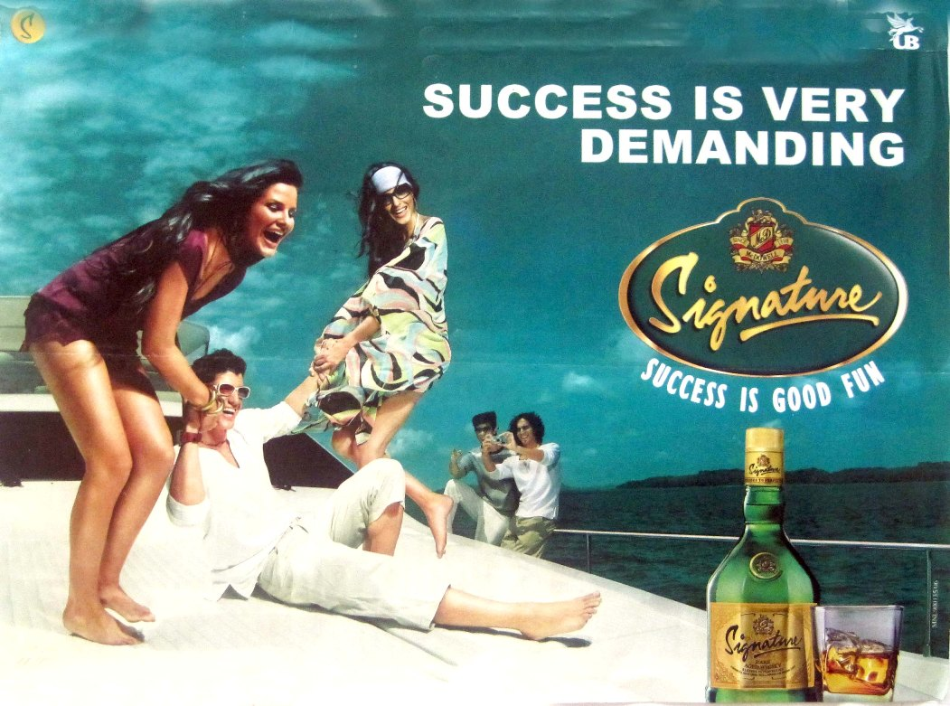

Choice #2 – Skinnygirl (Alcohol)

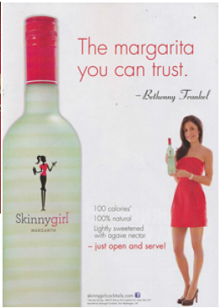

4. Give your “TOP FOUR HEALTH REASONS NOT TO SMOKE”.

*****insert answer here*****

5. Give your “TOP FOUR HEALTH REASONS NOT TO DRINK ALCOHOL UNDERAGE”.

*****insert answer here*****