# **Former hostage Joshua Boyle to have bail hearing in Ottawa today**

## Boyle, arrested Jan. 1, faces 19 charges against 2 alleged victims

CBC News · Posted: May 28, 2018 9:05 AM ET | Last Updated: 2 hours ago

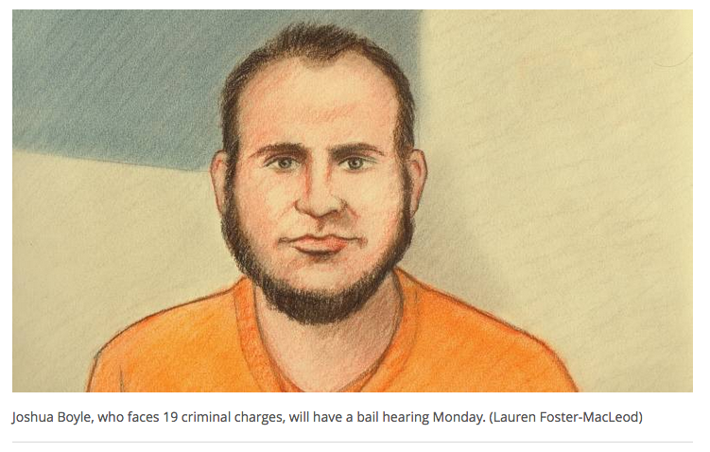

Former hostage Joshua Boyle, who faces a set of 19 charges related to alleged incidents after he returned to Canada in October, will have a bail hearing at the Ottawa courthouse today.

* [Former hostage Joshua Boyle makes brief in-person court appearance](http://www.cbc.ca/news/canada/ottawa/joshua-boyle-ottawa-charges-court-april-9-1.4608560)

After his arrest on New Year's Day in Ottawa, Boyle faced 15 charges relating to two alleged victims, including eight counts of assault, two counts of sexual assault, two counts of unlawful confinement, uttering a threat to cause death, public mischief, and administering a noxious substance.

Those original 15 charges were withdrawn by the Crown in January, and a new set of 19 charges were entered into the record. The practice is not uncommon, and is known as a relay of charges.

* [Psychiatric assessment for ex-hostage Joshua Boyle extended by 2 weeks](http://www.cbc.ca/news/canada/ottawa/joshua-boyle-ottawa-charges-court-march-26-1.4592918)

The 19 charges, which related to one alleged victim instead of two, are:

* One count of sexual assault while threatening to use a weapon (ropes).
* One count of sexual assault with a weapon (ropes).
* One count of uttering a threat to cause death.
* Nine counts of assault.
* One count of assault with a weapon (a broomstick).
* Three counts of unlawful confinement.
* One count of administering a noxious substance (the antidepressant Trazodone).
* One count of public mischief (misleading a police officer into believing that someone was suicidal and missing, causing the officer to start an investigation, and thereby diverting suspicion away from Boyle).
* One count of criminal harassment.

In an appearance April 9, the Crown told court it's changing the name of the victim for one of the 19 charges, and that there are two alleged victims. The identities of both alleged victims are protected by publication bans.

Police allege the offences happened in Ottawa between Oct. 14 and Dec. 30. None of the charges has been proven in court.

**'The kids and I are doing OK'**

Boyle, his American wife Caitlan Coleman and their three children were freed in October, five years after the couple was abducted while on a backpacking trip in Afghanistan. The children were born in captivity.

In an interview with *The Fifth Estate*'s Habiba Nosheen after Boyle's arrest, Coleman said she hopes Boyle gets the help he needs.

"The kids and I are doing OK given the circumstances," said Coleman.

* [Joshua Boyle, former Canadian hostage, faces 15 criminal charges](http://www.cbc.ca/news/canada/ottawa/joshua-boyle-ottawa-charges-1.4470475)
* [The Hostage Family: Life after Captivity (the Fifth Estate)](https://youtu.be/XExXz98lm9o)

Upon Boyle's return to Canada, he told CBC News that members of the Taliban-linked Haqqani network killed their infant daughter and raped his wife during their five years in captivity. The family was moved between 23 different locations within 50 kilometres of the Afghanistan-Pakistan border, and spent time in both countries.

Boyle said his family was shuffled among at least three prisons. One was remarkably barbaric, he said, while another one was particularly violent. He and his wife were frequently separated and beaten.

Boyle settled into his parents' home in Smiths Falls, Ont., when he returned to Canada in October, but court records show his most recent address was in Ottawa.

