Practice activity 1:
Read the following articles and complete the activity:
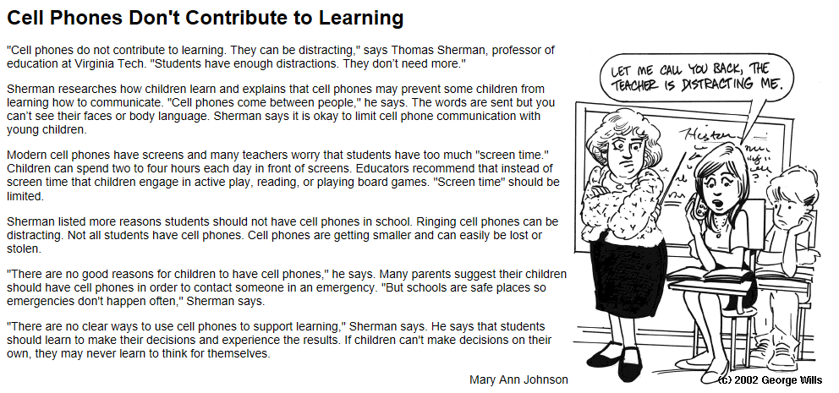

Reading and the Cell Phone: An Up and Coming Romance By Terence W. Cavanaugh
(FLORIDA READING ASSOCIATION. winter 2006) In this article, Dt'. Cavanaugh stretches our notions of literacy by providing examples of how technology, in this case cell phones, can be used for reading and writing.
Cell phones and schools are not usually associated together. at least not in a good way. But this form of technology is one that has been undergoing great leaps and improvements, and perhaps one day soon teachers will be reprimanding students for forgetting to bring their cell phones to class, or teachers will be listening to excuses from the student who didn't complete his reading homework because the phone battery was recharging.
Today cell phones seem to be everywhere and in nearly every hand. And before anyone dismisses the idea of using cell phones for reading, consider how readily available these tools are. The digital natives of today, also known as a member of the Millennial Generation, seem to have been born with a cell phone, to the extent that in 2003, over 43% of school aged children owned at least one wireless device (Patrick 2004). Breaking down that statistic you will find that in 2003, 70% of middle and high school students and 610/o of upper elementary students had cell phones (Branigan 2004), and the numbers have only been growing since then.
First let's think about the phone. Today's cell phones have a number of interesting functions and abilities beyond just voice communication. One f-actor of the constant technology growth is that today's better cell phones actually have the computing power of a mid 1990's personal computer (Prensky 2004). Now, a number of cell phones also have the ability to use removable memory cards, which can be used in the phone and in a computer. Almost all cell phones now can send and receive text messages, do note-taking (as voice or text), have calendars, and the ability to play games - which actually means that they can run additional software programs. Some phones have abilities which are becoming more common, such as being able to browse the Internet or play Mp3s.
What does this have to do with reading? Well for one thing, students are already reading their phones: texting or messaging has become a common tool for students. What I'm suggesting is that teachers starl thinking about using the communication tools that students already have, are using, and are quite comfortable with. Let's start having our students use their cell phone also as a reading tool - Books on Phone. One of the early cell phone books to receive a lot of attention was written by an author in Japan named Yoshi, who self-published a book titled Deep Love as a serialized book that was distributed as downloadable text files to be read on celI phones (Steuer 2004). Within three years of its release the cell phone book's download site had accumulated over 20 million hits, being very popular with female teen readers.
Already there are a wide variety of book types available for cell phones, including non-fiction, poetry. graphic novels, short stories, and whole novels. For the cell phone, these electronic books break down into three basic formats: audiobook, web book, and Java book.
In some ways the modern cell phone is like the VCR of yesteryear - remember the flashing clock that perhaps you or your parents couldn't get to stop. Enter the digital native: children took to VCRs and cable television programming and used them with what seemed like instinct. Today cell phones occupy a similar niche in the technology environment, so if you realty want to know what your cell phone can do, sit with a teenager and get him or her to take you through step by step some of the options and abilities of your phone.
Terence W. Cavanaugh is an instructor in the College of Education end Human Services at the University of North Florida, Jacksonville, Florida.

1. Underline the facts in the article. Can they be validated?
2. Circle the opinions.
3. Looking at the opinions, what is the prevailing tone? Is it positive or negative?
4. What do you know about the writer of the article?
5. How might experiences or objectives “color” this writer’s opinions?
6. Do you think the writer intentionally uses bias to persuade, or it is unintentional?
7. How biased is the article? Can the writer be trusted, or is the bias too strong for a clear understanding of the topic?
Practice activity 2:
Read the following paragraph, and then try to determine whether there is bias, using the information, questions, and suggestions from above. If so, what might be creating the bias?
Read the next two examples. Is there bias in both? Is it interpreted in the same way? Why or why not?
Eating an orange everyday is one of the best things you can do for yourself. These gorgeous, bright and vibrant fruits not only taste amazing, but help to make your plate more appealing. Research has shown that people that eat an orange everyday not only lower their cholesterol and the risk of cancer but also find they have more energy and can maintain a healthy weight through adulthood. - Orange Growers of Canada
Eating an orange everyday is one of the best things you can do for yourself. These gorgeous, bright and vibrant fruits not only taste amazing, but help to make your plate more appealing. Research has shown that people that eat an orange everyday not only lower their cholesterol and the risk of cancer but also find they have more energy and can maintain a healthy weight through adulthood. - Dr. Best Medicine

