2.1 Effective Searching
1. An environmental issue like climate change or garbage waste is a large one which you may not know a lot about. Choose one of the issues below:
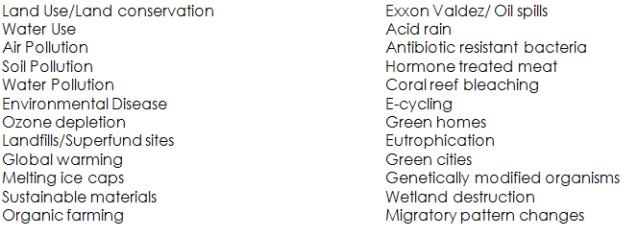
2. Search the internet to find ten related but narrower topics or subtopics and key concepts on your selected environmental issue. Consider the following questions as you research your chosen topic.
- Define the environmental issue you are covering.
- What is the history behind the issue?
- Who are the major “players” involved in the issue (government agencies, local townspeople, private or public organizations, etc)?
- What are people doing to help prevent or change the issue?
- How does this issue have an impact on humans and the environment now and in the future?
3. Try each of these 8 search strategies as you begin to accumulate information on your chosen topic. Copy and paste your results (just a brief extract) from each of these strategies into the worksheet. Consider what the resource will contribute to your final presentation.
- Try an initial search and then write down synonyms or other related terms that you might use to create a subtopic. For example, I typed "computer recycling" into the metadata site Wikipedia and the result showed me 4 other links to entries in Wikipedia as potential subtopics. Can you spot them? I could also use the synonyms "electronic recycling" or "e-waste recycling" to narrow and refine my search.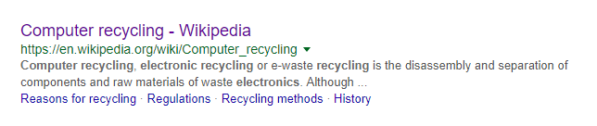
- Use a search engine like Yahoo or Google. The words you use will determine the information you find. So use different words in your search to give you additional information. When using a multiple keyword search, put the most important keywords first.

- Search by Related Content found at the bottom of your initial search.

- Use quotations around the words to locate sources with exactly that phrase. Otherwise, most search engines will look for each word separately.
Eg. "computer recycling" vs computer recycling
*Use a plus sign + in front of a word to require its inclusion (no space between the sign and the word). A word or phrase preceded with a + sign must be present in the search results.
*Use a minus sign – in front of a word to require its exclusion (no space between the sign and the word). A word or phrase preceded by a – sign will exclude that word in the search results.

- Search by different types of content. Go to Google and under the search box choose to sort by video, or images, or news, or books.

- Search for a list of resources or sites: “best sites for environmental issues” or “top recycling resources”.

- Use a social media tool like Twitter search.

- Search for a specific filetype by typing .pdf or .ppt or .png in the search.

- Once you have found a site that looks applicable, search your topic just on that site. This is only possible if the site has a search function on it.

