2.1 Effective Searching
EXAMPLES:

- After your initial search, notice synonyms or other related terms that you might use to create a subtopic.

Search: computer recycling
Sub-topic: Types of programs (city (like Victoria), businesses (like Best Buy)
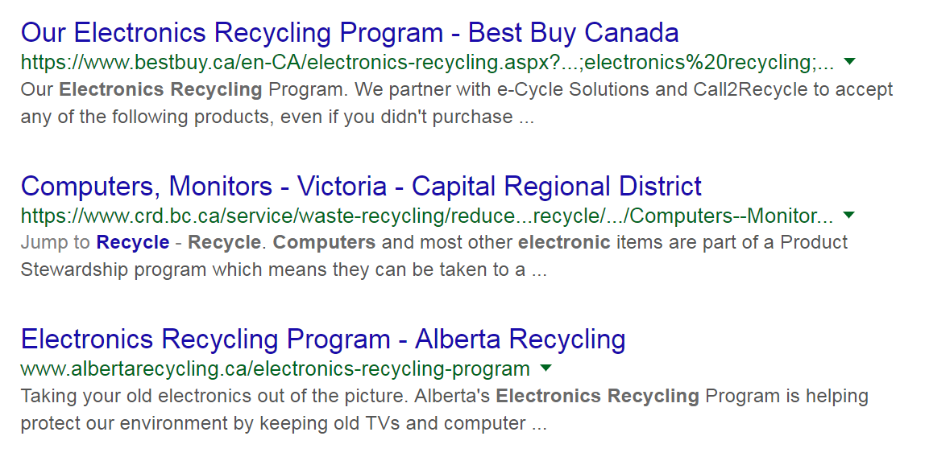

- Try a metadata site such as Wikipedia, or a social media tool like Twitter search
Search: https://en.wikipedia.org/wiki/Computer_recycling
Sub-topics: see snippet:
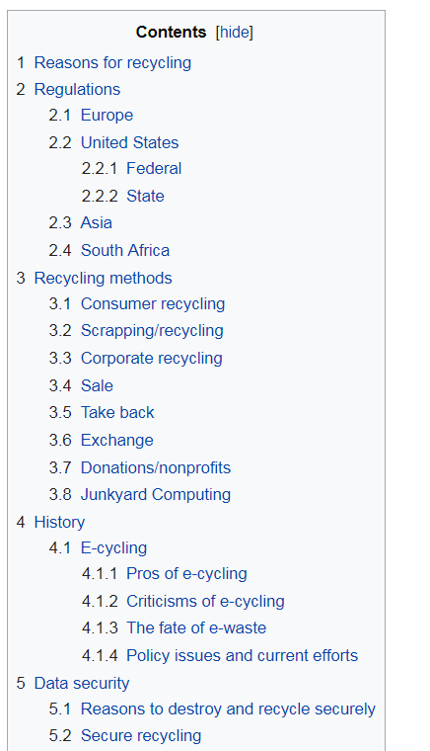
- Search by different types of content. Go to google and under the search box choose to sort by video, or images or news or books.
Search: reusing electronics (google videos)
Subtopic reusing electronics
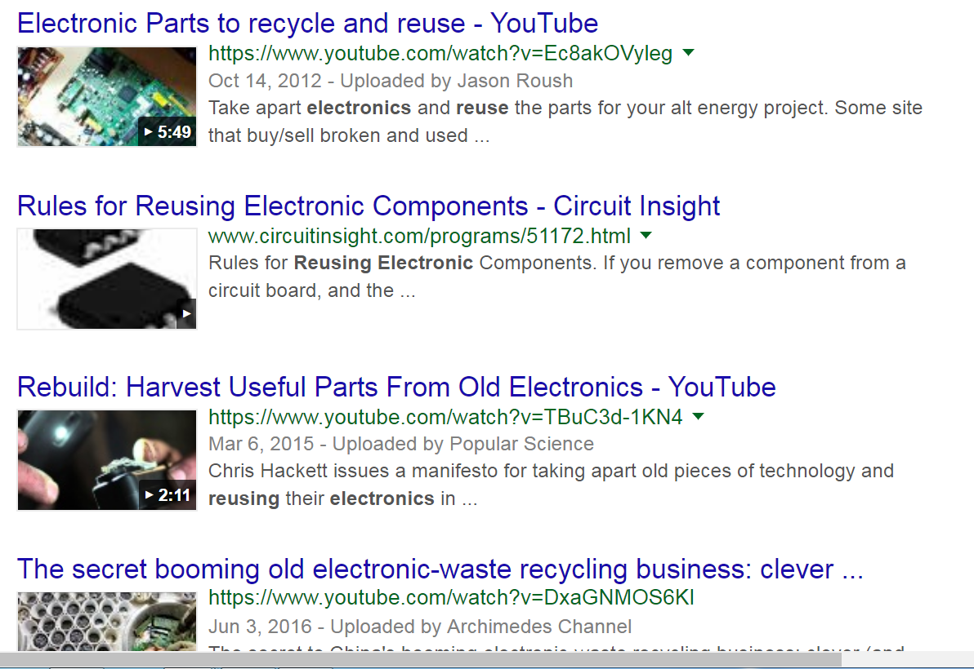

Try a wildcard search if applicable: eg organic farm*
Search: e-cycle*
Subtopics: price locations
e-cycle india
e-cycle price

- Use quotations around the words to sources with exactly that phrase: eg. “wetland destruction”
Search: “e-cycling sub-topics”
No result but clicked on first article, skimmed and found sub-topics: e-waste, and redistributing electronics.

- Review the related search at the bottom of your search and click on one to find a narrower search.
Search: clicked on electronic recycling for cash
Sub-topic: e-cycling for cash

- Try searching for a specific filetype by typing :pdf or .ppt or .png in the search
Search: e-cycling .ppt –didn’t find a .ppt right away but led to title of a book about trash and health
Sub-topic: Human health and e-cycling

- Try searching for a list of resources, or sites: “best sites for environmental issues” or “top recycling resources”
Search: bests e-cycling resources
Sub-topic: types of e-cycling businesses

- Once you have find a site that looks applicable search your topic just on that site using site: +the url plus the keywords. Eg: site: www.enn.com "water conservation"
Search: site: +www.greenpeace.org/international/en/campaigns/detox/electronics/Guide-to-Greener-Electronics/ecycling
Sub-topics: green electronics

- Google can be biased. For example if you search in videos you will only get youtube videos not vimeo. So try a few different search engines.
Search: (using Dogpile: e-cycling)
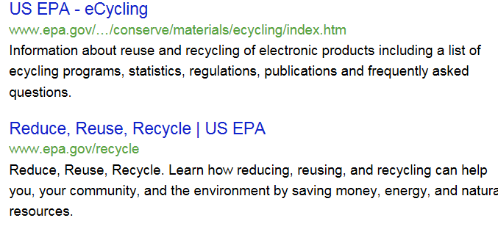

Subtopic: regulations around e-cycling.

